Interview Exchange Step-by-Step Guide for Student Employee Onboarding
The Student Employee Onboarding process (for non-work study student employees) must be generated after the Student Hire Form has been processed and approved by the task approvers. The Hiring Manager will access the Student Employee Onboarding process through the Onboarding Module on Interview Exchange. The Student Employee Onboarding Process includes the (1) Student Employment Contract, (2) i-9, (3) W-4, (4) M-4, and (5) Direct Deposit form. The Student Employment Contract must be issued to every student employee hired for a student position. The I-9, W-4, M-4, and direct deposit forms should only be issued to new student hires.
Note: Supervisors/Managers who hire and onboard non-work study student employees will need additional access to the Onboarding Module within Interview Exchange to access and process important documents for student hires. If you are a supervisor that generally hires student employees, please contact an HR administrator to inquire about getting access to the onboarding module within the Interview Exchange system.
- After signing into Interview Exchange, click on the Interview Exchange Onboarding/Contracts Module:
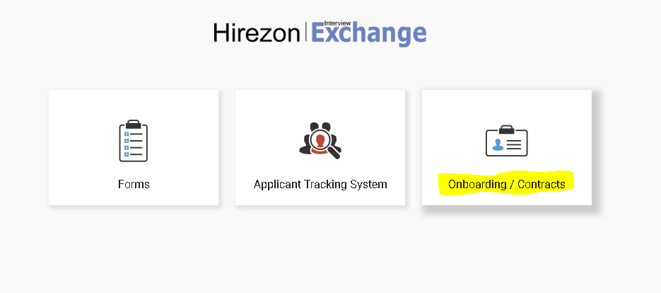
- This screen is called your “Dashboard”. This is where you will see all onboarding packets that you’ve completed or are still pending. Click on “Start New Packet”.
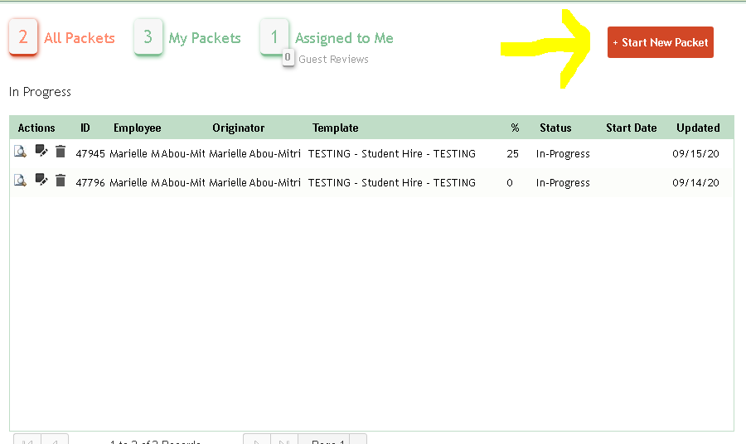

- The next screen is the “Start New Packet” screen.
  - You will be required to enter the Title, Name, Email, and Department for the employee you are onboarding. Please note: The email should not be a Middlesex Community College email address.
  - Choose Student Hire in the dropdown for the Template.
  - Click Create.
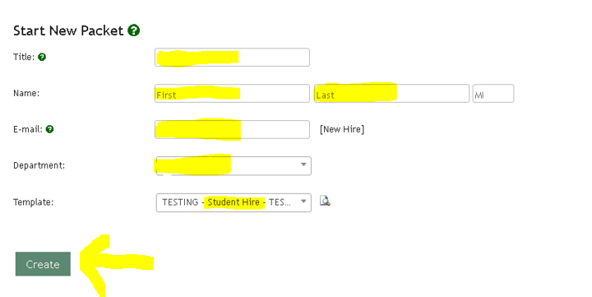
- After you click Create, you will be directed to review a series of documents which you may include in the student employee’s onboarding package. Please note: You will not need to include all of these documents in the onboarding package for every student hire. You will need to determine which documents/forms/policies apply to your student hire. The standard Student Hire Onboarding Package includes (1) an Electronic Communication and Signature Consent Form, (2) an Employment Contract, (3) an I-9, (4) a w-4, (5) an M-4, and (6) a Direct Deposit Form. Please Note: The Electronic Communication and Signature Consent Form and the Employment Contract will always need to be issued to Student Employees, whether they are new or returning. The I-9, w-4, M-4, and Direct Deposit forms are only required for new student hires.
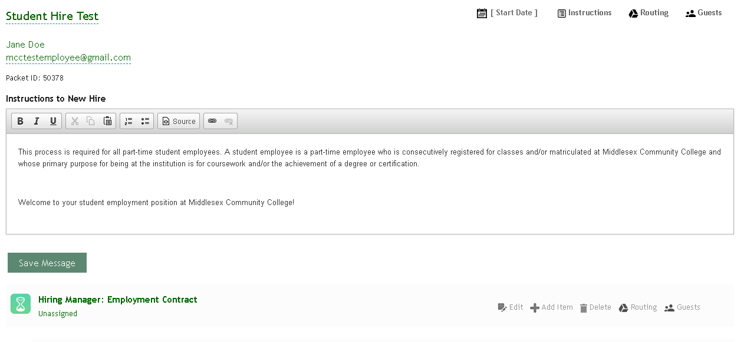
- While on this screen you will see an hour glass icon to the left of each heading. Clicking on the hour glass icon will allow you to see the documents associated with the heading.
- If you do not want to include specific forms in your onboarding package, for example, the I-9, W-4, M-4, or Direct Deposit form, you may click on the delete button to the right of each form to remove it from your onboarding package. You will need to review each form on the list and determine its applicability to your student hire.
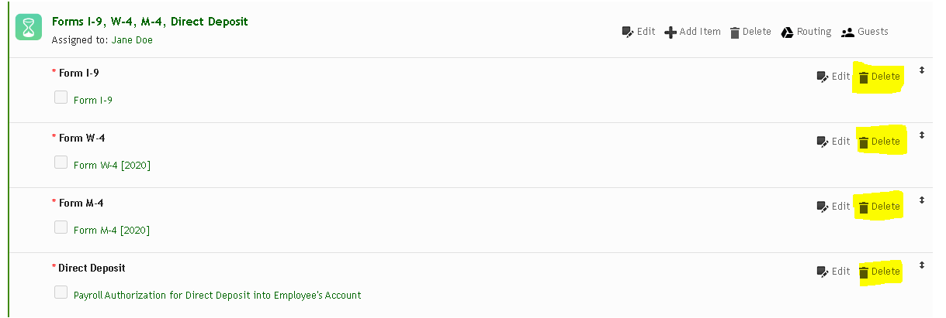
- Once you’ve determined which forms you would like to include in the student onboarding package, the Employment Contract will need to be assigned to you, as the Hiring Manager. Click on “Unassigned” under the Employment Contract heading. Also, you should see that any documents requiring submission from the student employee will already be “Assigned to” the student employee being hired.
- Enter your name, as the Hiring Manager, in the “Assignee Name” field. Your name should prepopulate as you begin to type it in. You may search by first or last name.
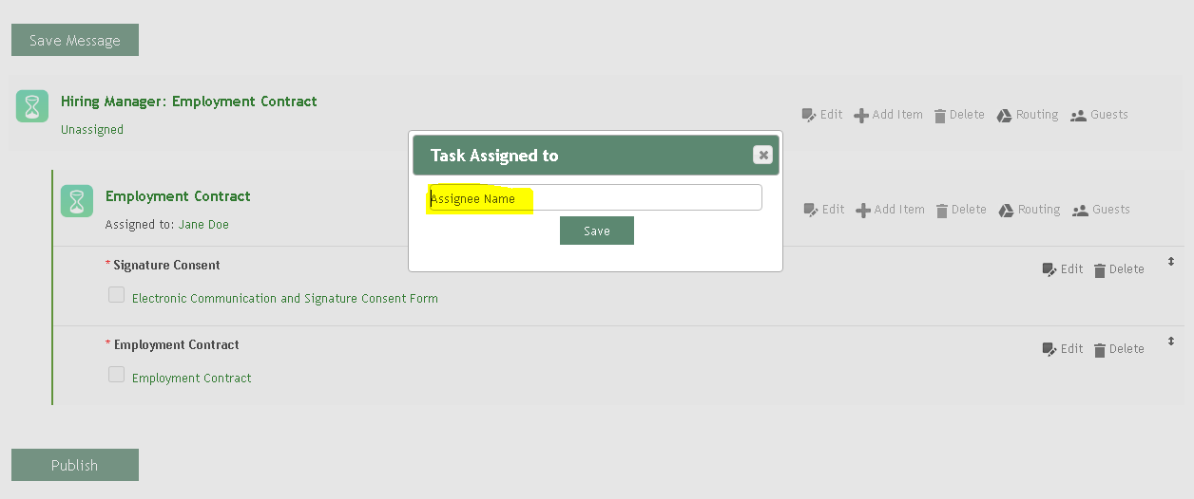
- If you’ve properly assigned the document to yourself, as the Hiring Manager, your name will prepopulate under the Employment Contract under the “Assigned to” field.
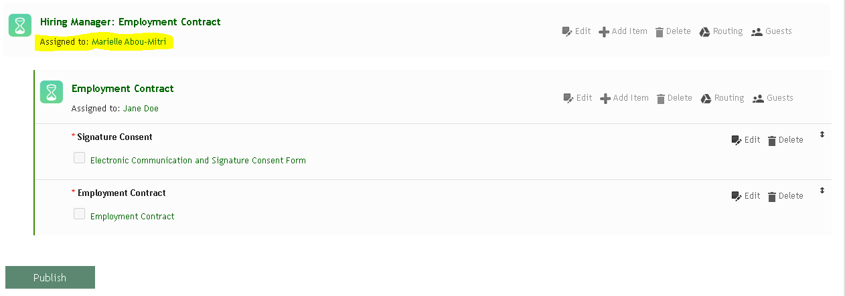
- Click “Publish”.
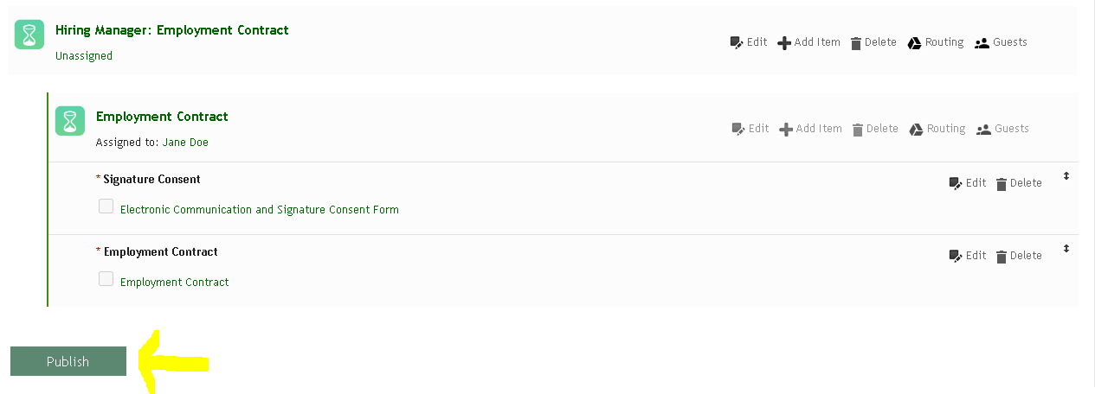
- If you are the Hiring Manager that was assigned to the Employment Contract you will then be brought to the following screen. You will see that there is now an arrow to the left of the Employment Contract, indicating that you have a task that needs to be completed. Click on “Complete Task” to fill out the Employment Contract.

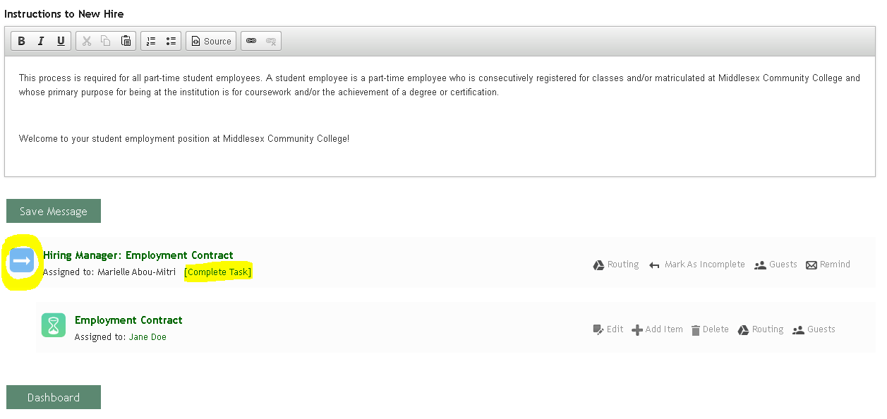

- Click on “Hiring Manager: Employment Contract” to access the form.
- Click on “Employment Contract”.
- Fill out the Employment Contract with the specific information for your student employee. Then click “Save & Continue”.
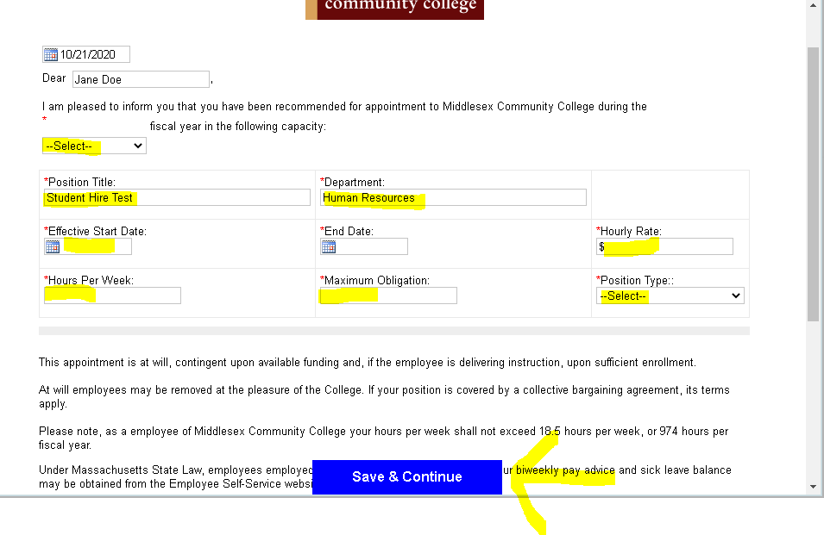
- You will have the chance to review the Employment Contract before submitting it. If you want to make more edits to the form, click “Edit”. Otherwise, click “Continue”.
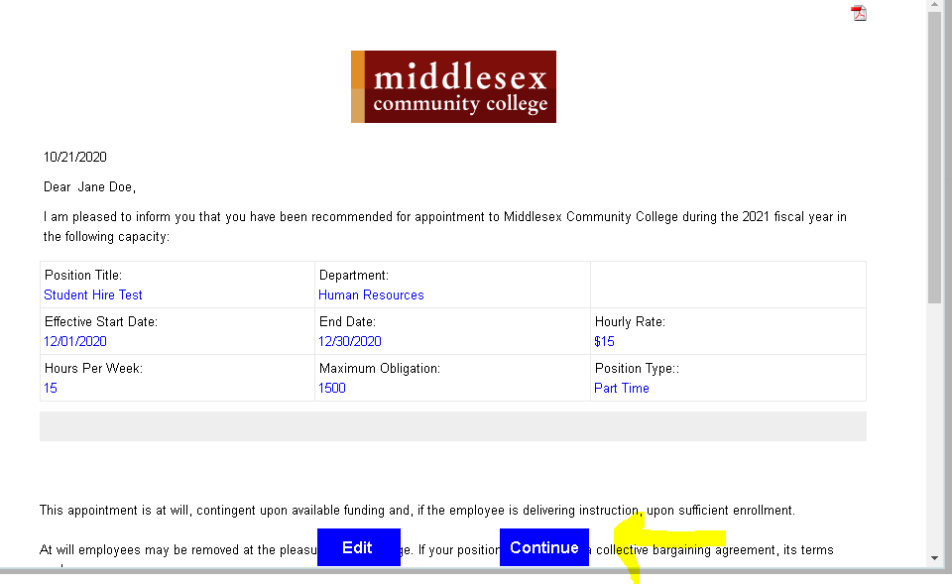
- You will now see a green check mark in front of the Employment Contract. This indicates that you have completed the form. Then click “Save & Submit”.
- You’ve now completed the Onboarding Package. The student employee will receive an email providing them with more information on submitting any contracts or forms.
