Interview Exchange Step-by-Step Guide for Renewal Request Form
The Renewal Request Form is used for all current part-time employees with expiring annual or short term contracts. This form replaces the JAF but can only be used for returning employees. (If you are hiring a new employee, you must use the Hiring Request Form.) Once the Renewal Request Form is generated and approved by the task approvers, the Hiring Manager issues the employee an Employment Contract through the Forms Module.

- After signing into Interview Exchange, click on the Interview Exchange Forms Module:

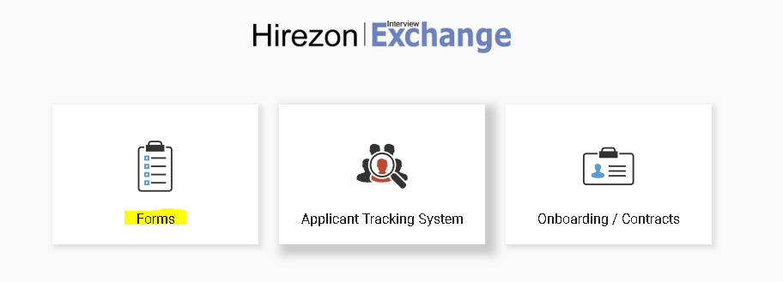
- This screen is called your “Dashboard”. This is where you will see all forms that you’ve completed or are still pending. Click on “Start New Form”.
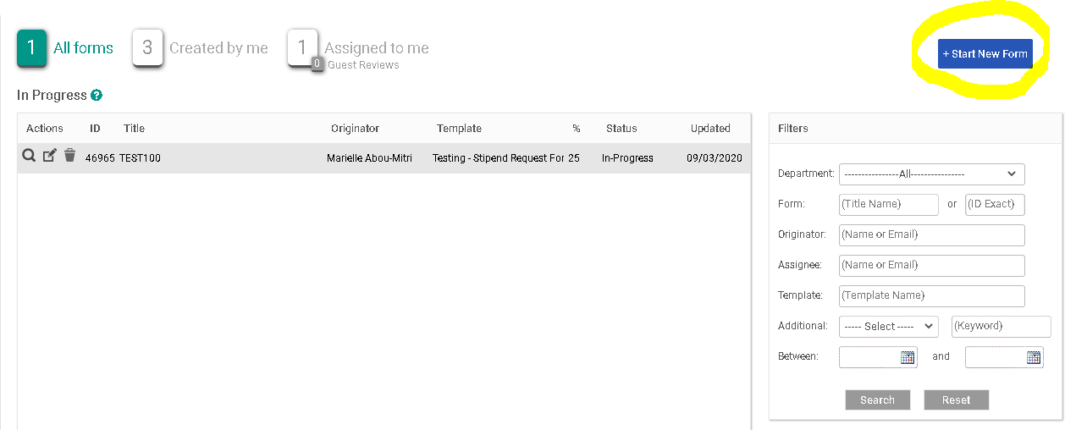
- The next screen is the “Start New Form” screen.
  - You will be required to select the correct department from the Department dropdown list. Note: You will not be able to change the department once the form is created.
  - Select the corresponding category from the Category (Personnel) dropdown.
  - Select the required template from the Template (Renewal Request Form) dropdown. Once the template is selected, you can preview the template by clicking the magnifying glass icon.
  - Enter a Position Title/Name in the Title/Name field.
  - Click Create Form.
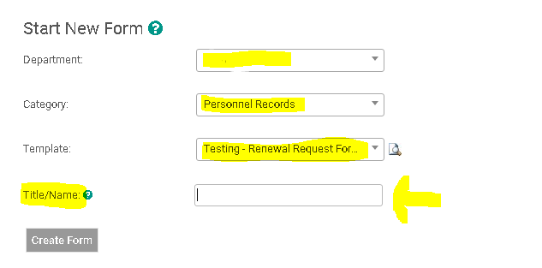
- After you click on “Create Form” you will be directed to the following page to complete a series of tasks. Click on “Staff Renewal Request Form”.
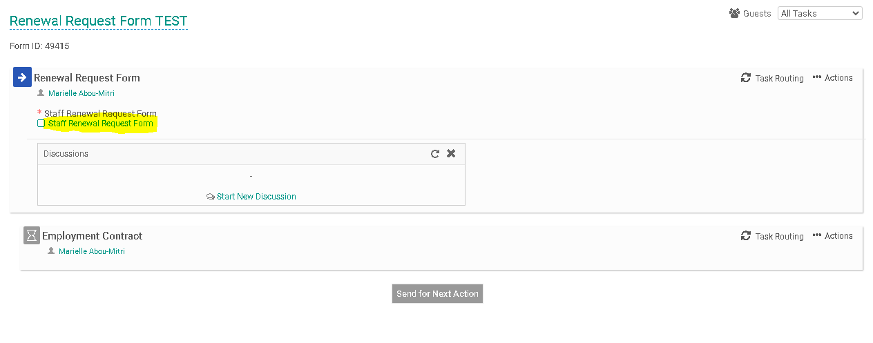
- Fill out the specific information in the required fields regarding the position you are renewing. This information includes (1) Current Employee’s Personal Information; (2) Classification Group; (3) Compensation; (4) Work Schedule and Location; and (5) Budget Information. When you have finished filling out the form click, “Save & Submit”.
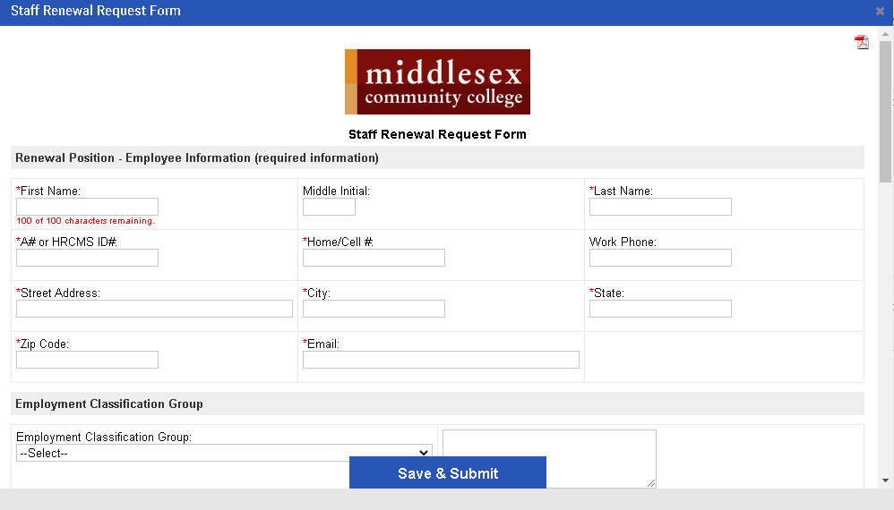
- You will then be prompted to review the information you submitted on the form. You can click “Edit” if you would like to make changes. Otherwise, click “Continue”
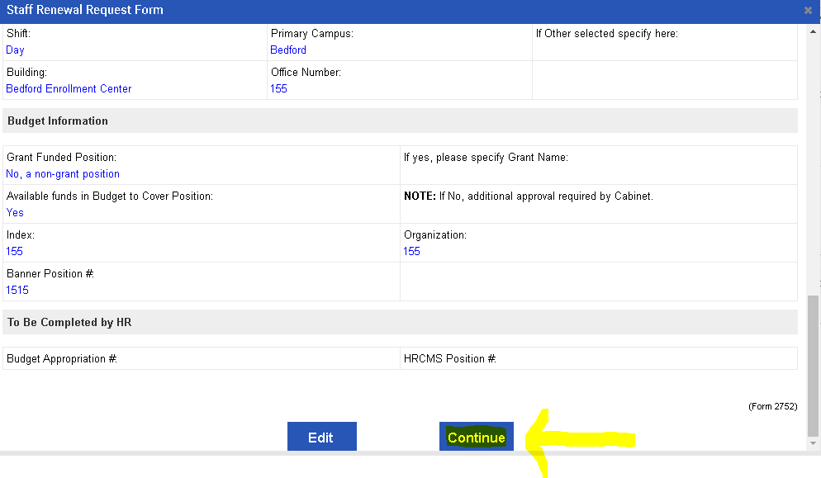
- Your screen should now indicate a small check mark in front of the “Renewal Request Form” to indicate that you’ve completed this task.
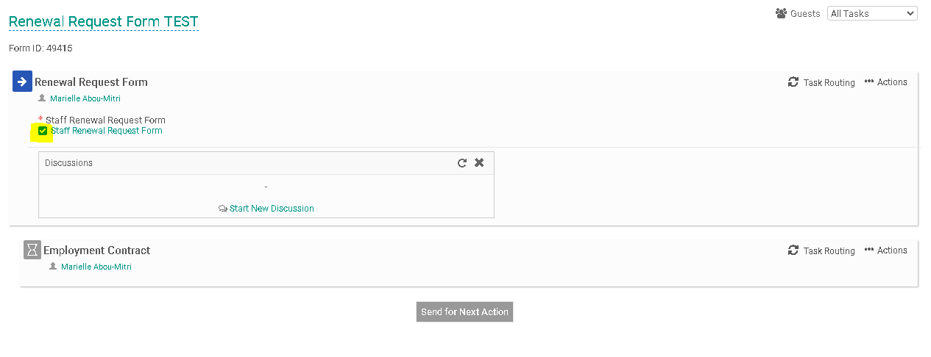
- Your next step will be to generate the Task Routing process so all parties involved may approve your Renewal Request Form. Click on “Task Routing” to begin this process.
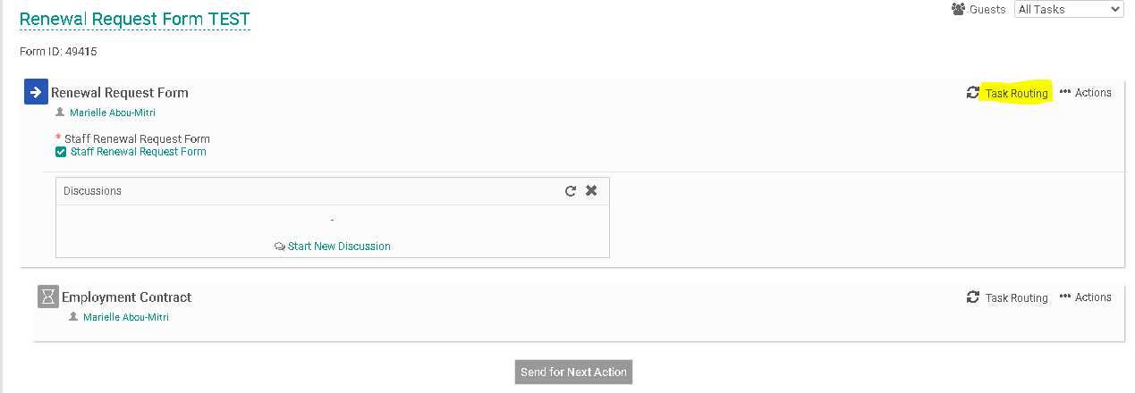
- Certain people in the task routing screen are prepopulated. On the Renewal Request Form, the Human Resources and Finance representatives are prepopulated. The person filling out the Renewal Request Form will be required to enter a name for the “Hiring/Cost Center Manager” and the “Senior Leader/Cabinet Representative”.Click on the Edit Routing User Icon (highlighted below) alongside the Hiring/Cost Center Manager to enter a name for this field.
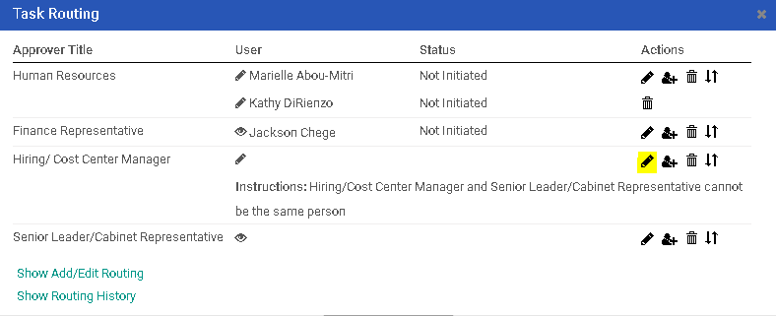

- Enter the Hiring/Cost Center Manager into the “User” field. As you type this person’s name, the system will recognize people with accounts in the system and will prepopulate the field. You may search for the employee using the employee’s first or last name. Click “Save Routing” once you have entered the field.
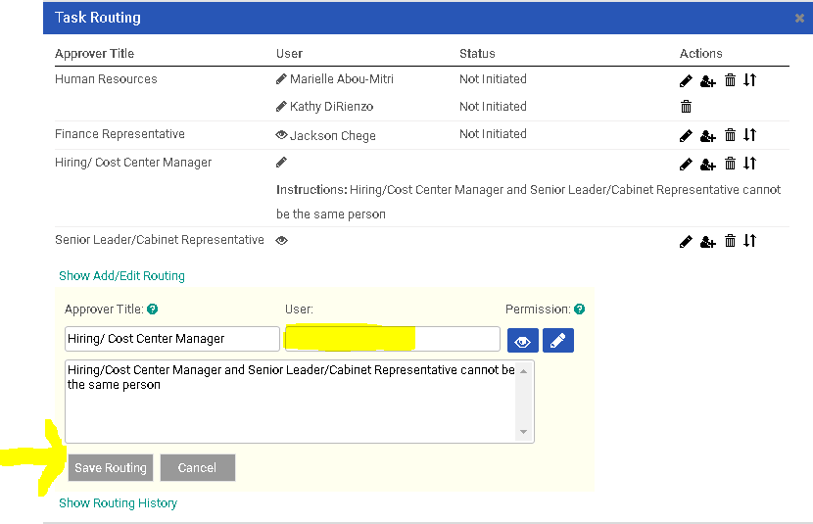

- You will be required to complete the same action for the Senior Leader/Cabinet Representative. Click on the Edit Routing User Icon (highlighted below) located to the right of the Senior Leader/Cabinet Representative field to enter a name.
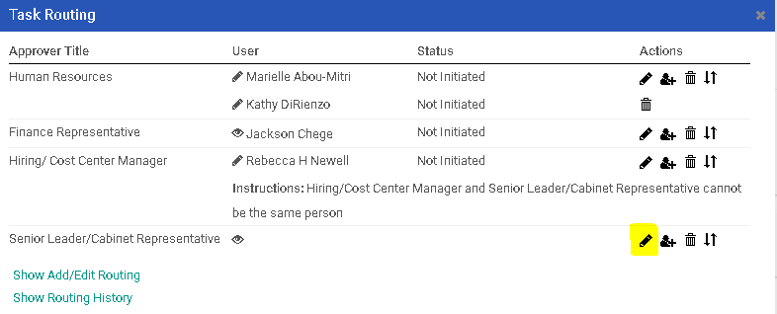
- Enter the Senior Leader/ Cabinet Representative into the “User” field. As you type this person’s name, the system will recognize people with accounts in the system and will prepopulate the field. You may search for the employee using the employee’s first or last name. Click “Save Routing” once you have entered the field.
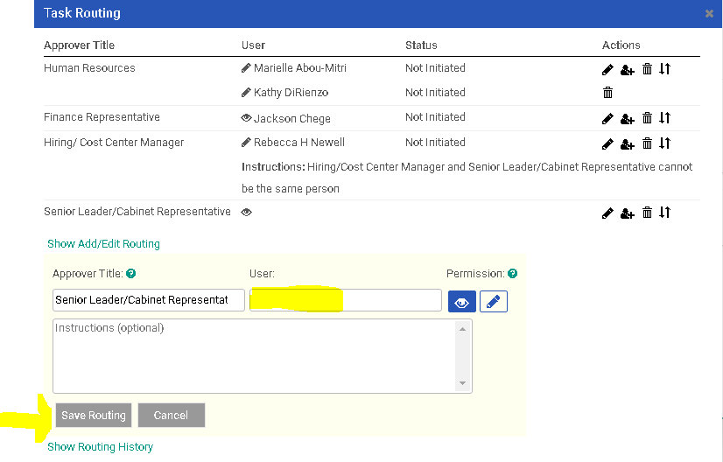

- The employee receiving the Renewal Request will also need to be added to the task routing in order to receive the Employment Contract. Click on the “Task Routing” field to the right of the “Employment Contract” heading.
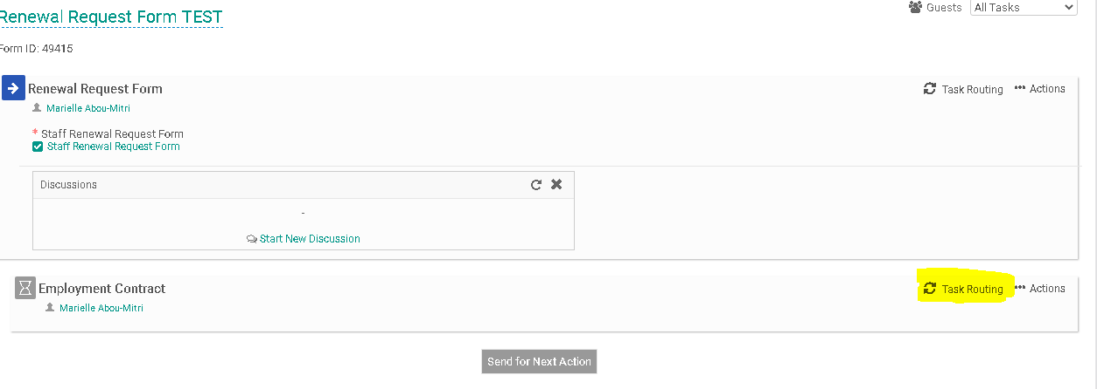
- Click on the Edit Routing User Icon (highlighted below) located to the right of the Employee field to enter the employee’s name. 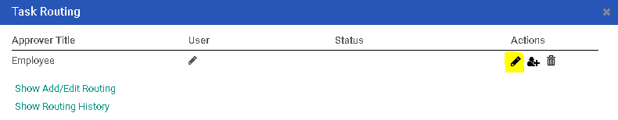

- Enter the Employee’s name into the “User” field. As you type this person’s name, the system will recognize people with accounts in the system and will prepopulate the field. You may search for the employee using the employee’s first or last name. Click “Save Routing” once you have entered the field.
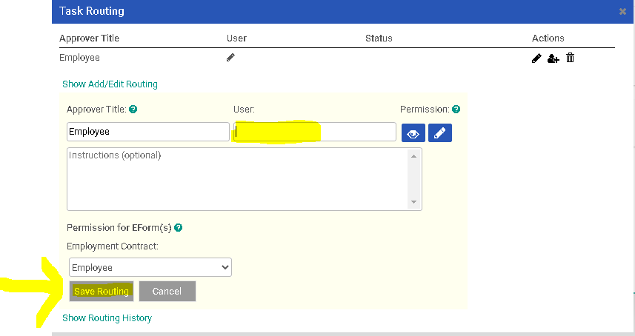
- Next, you will need to click on “Send for Next Action”. This will allow for each person in the task routing field to review the Renewal Request Form and approve/deny/edit it. Each person in the task routing field receives an email notification when it is their turn to review the form.
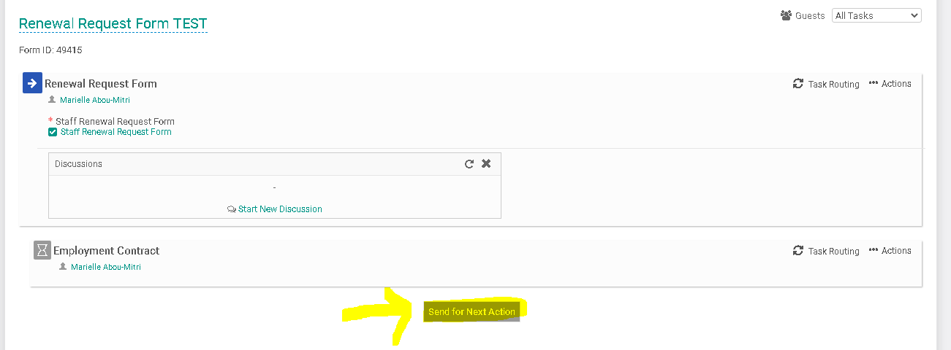

- If you are one of the approvers in the Task Routing of the form, please review the Interview Exchange Step-by-Step Guide for Task Routers.
- Once the Renewal Request Form has been approved by all of the task routers, the Hiring/Cost Center Manager will receive an email notification to complete the Employment Contract. Return to the Forms Module. The screen below is known as your “Dashboard.” Click on the number to the left of the “Assigned to me” heading. Then click on the “Edit” icon that corresponds to the Renewal Request form you need to complete.

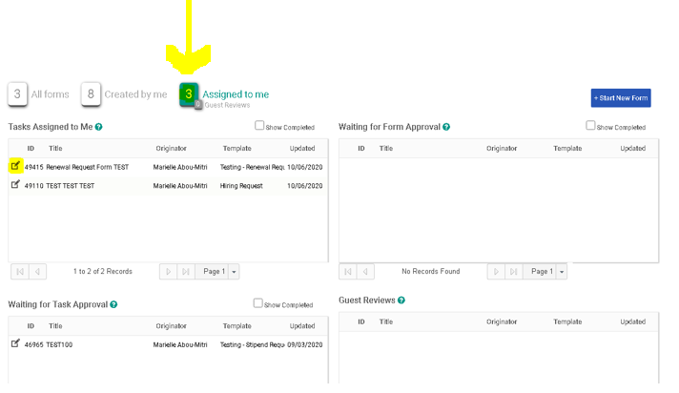
- Click on “Employment Contract”. This will allow you to access the employment contract which will be sent directly to the employee receiving the Renewal Request Form.
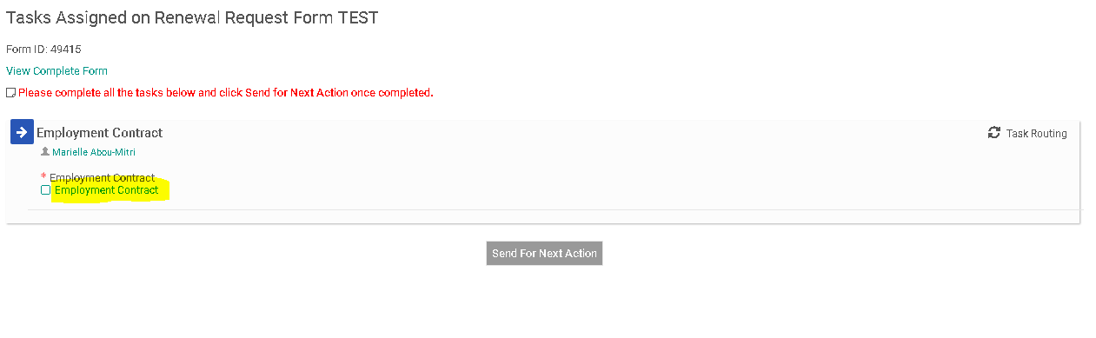
- Enter the information into the required fields. All of the information provided on the Employment Contract should be the same as the information that was previously submitted on the Renewal Request Form. Click “Save & Submit” once you are done.
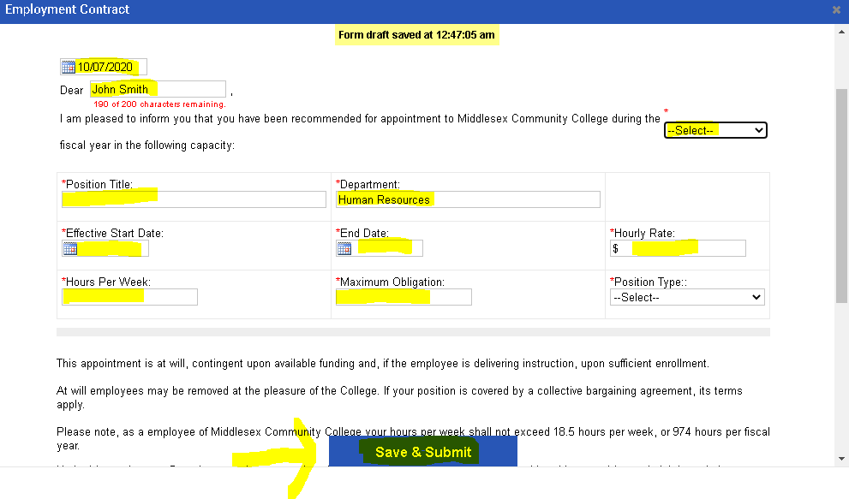
- Review the information you submitted on the Employment Contract and press “Edit” if you wish to make more changes or “Continue” if you are done.
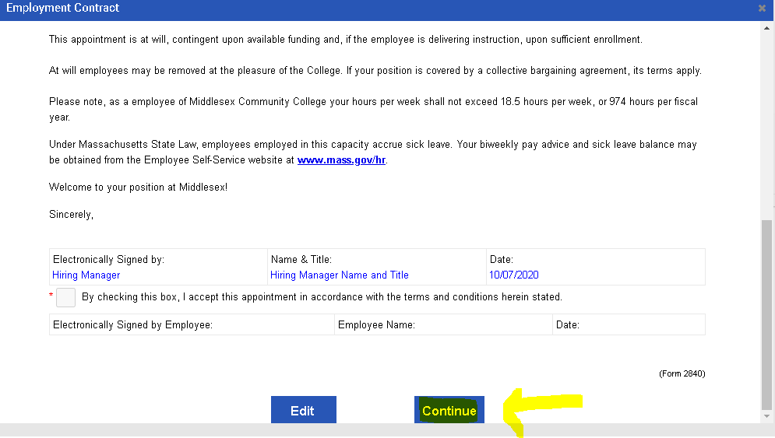
- You will now see a small check mark to the left of the Employment Contract. This means that you’ve completed this task. Click on “Send for Next Action”.
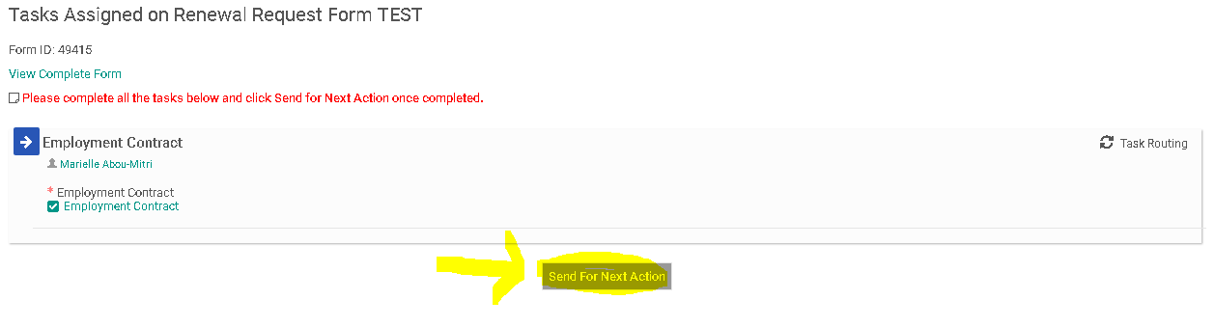
- The employee receiving the Employment Contract will now be issued an email notification to their MCC email account informing them about the Employment Contract.
