Interview Exchange Step-by-Step Guide for Employee Onboarding
The Employee Onboarding process must be generated after a candidate has been selected by the search committee as the hire for a position. The HR Representative will access the Employee Onboarding process through the Onboarding Module on Interview Exchange. The Employee Onboarding Process includes the (1)Offer Letter/ Employment Contract, (2) HR Forms required for hire, (3) Payroll forms required for payroll processing, (4) Policies and Procedures, (5) Benefits Information.
- After signing into Interview Exchange, click on the Interview Exchange Onboarding/Contracts Module:
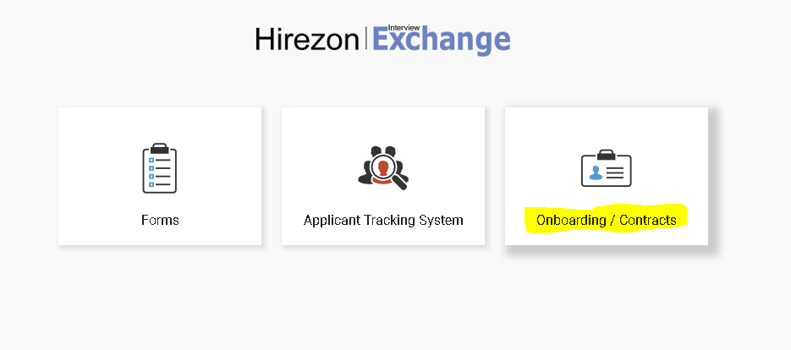
- This screen is called your “Dashboard”. This is where you will see all onboarding packets that you’ve completed or are still pending. Click on “Start New Packet”.
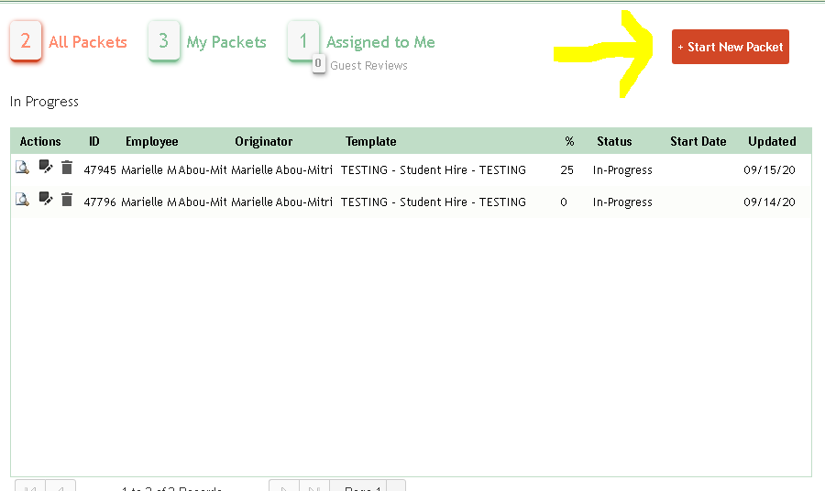
- The next screen is the “Start New Packet” screen.
  - You will be required to enter the Title, Name, Email, and Department for the employee you are onboarding.
Please note: The email should not be a Middlesex Community College email address.
  - Choose New Hire in the dropdown for the Template.
  - Click Create.
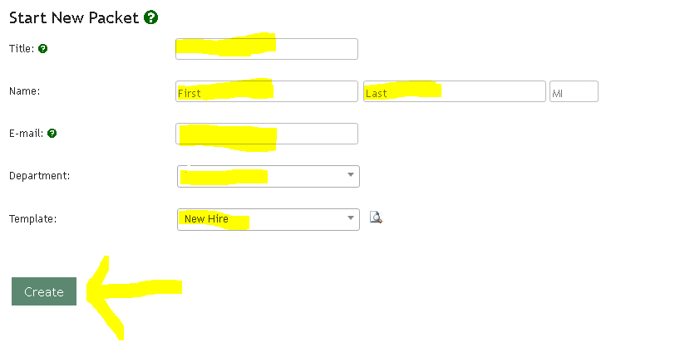
- After you click Create, you will be directed to review a series of documents which you may include in the employee’s onboarding package. Please note: You will not need to include all of these documents in the onboarding package. You will need to determine which documents/forms/policies apply to your new hire. The standard Onboarding Package includes (1) an Electronic Communication and Signature Consent Form, (2) an Offer Letter OR Employment Contract, (3) a Statement of Confidentiality, (4) a Transcript Request Form, (5) a Social Security Form, (6) a Veteran Self Identification Form, (7) a Voluntary Disclosure Form, (8) a Voluntary Self-Identification of Disability Form, (9) an I-9, (10) a W-4, (11) an M-4, (12) a Direct Deposit Form, (13) a Payroll Public Records Exemption Form, (14) a Accounts Payable Direct Deposit Form, (15) a Paid Family and Medical Leave Acknowledgement Form, (16) a Campus Parking Permit, (17) a New Employee Request for Technical Services, (18) Review of HR’s Policies and Procedures, (19) GIC Benefits Guide, and (20) Massachusetts Deferred Compensation SMART Plan OBRA.
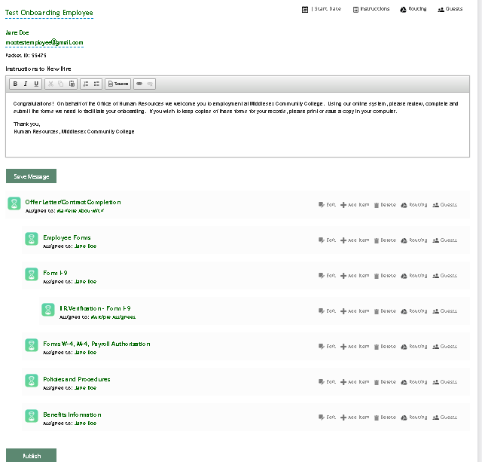

- While on this screen you will see an hour glass icon to the left of each heading. Clicking on the hour glass icon will allow you to see the documents associated with the heading.
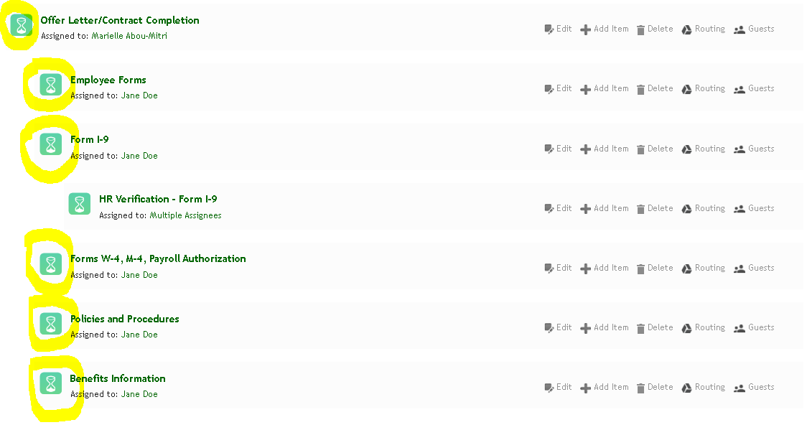
- If you do not want to include specific forms in your onboarding package, you may click on the delete button to the right of each form to remove it from your onboarding package. You will need to review each form/policy on the list and determine its applicability to your new hire. For example, you will need to determine which offer letter/contract of employment will be issued to the new hire depending on their employment classification. Further, if you are hiring a full-time employee you will want to leave the GIC Benefits Guide but remove the Massachusetts Deferred Compensation SMART Plan OBRA.

- Once you’ve determined which documents you would like to include in the onboarding package, confirm whether the documents are assigned to the correct individuals. The Offer Letter should be assigned to you, while the other documents, requiring employee review and submission, should be assigned to the new hire. Please note: If any documents state, “Assigned to: Unassigned” Click on “Assigned to: Unassigned” and assign the document to the correct individual. You will be able to enter the name of the individual you wish to assign the document to.
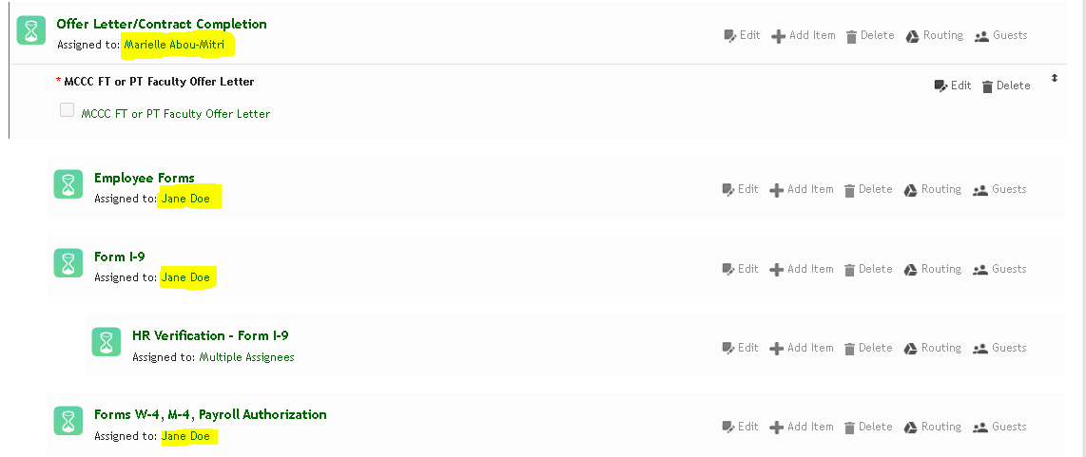

- Once you have determined all the forms you want to include in the onboarding package. Click “Publish”.
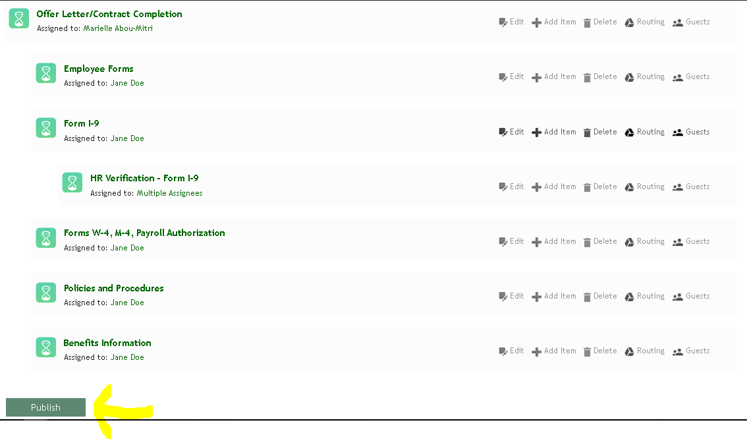
- You will now have to fill out the offer letter or contract of employment, which you previously assigned to yourself. You will see that there is now an arrow to the left of the Offer Letter, indicating that you have a task that needs to be completed. Click on “Complete Task” to fill out the Offer Letter.
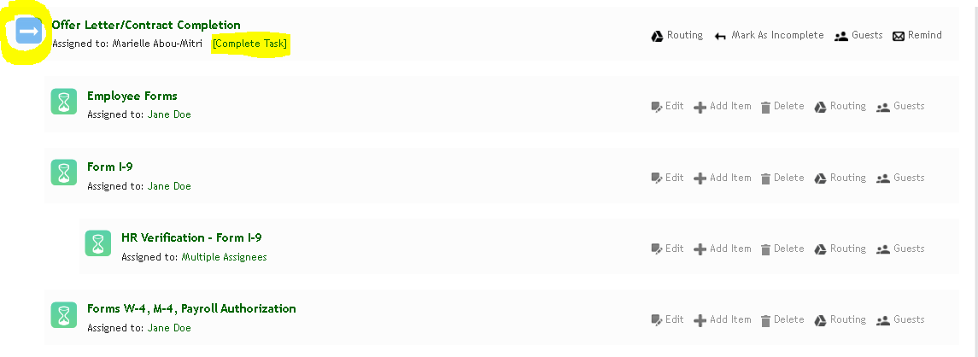
- Click on “Offer Letter/Contract Completion” to access the letter.
- Click on the name of the offer letter/contract to generate the document.
- Fill out the document with the specific information for your employee. Then click “Save & Continue”.
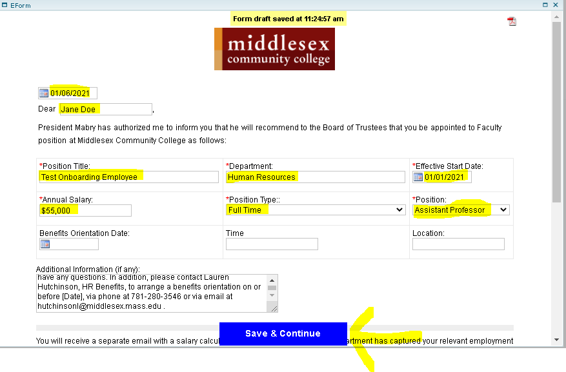
- You will have the chance to review the Employment Contract before submitting it. If you want to make more edits to the form, click “Edit”. Otherwise, click “Continue”.
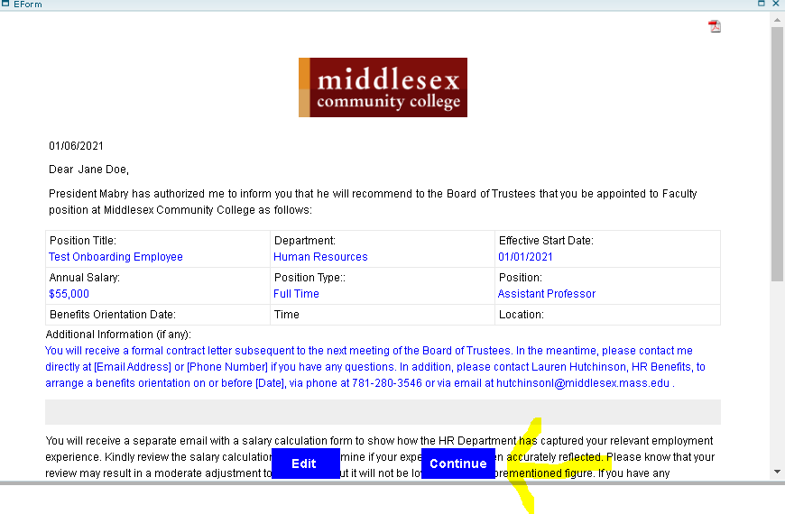
- You will now see a green check mark in front of the Offer Letter/Employment Contract. This indicates that you have completed the form. Then click “Save & Submit”.
- You’ve now completed the Onboarding Package. The employee will receive an email providing them with more information on submitting/reviewing any contracts, letters, or forms.
