Interview Exchange Step by Step Guide for Duplicating Exit Form
This guide will assist managers when there is a need to submit multiple exit forms for numerous employees. The manager generating the Exit Form will be able to duplicate an exit form so that the information is prepopulated on the form.
The Interview Exchange Step by Step Guide for Exit Form should be reviewed first, then follow the steps below.
- Follow steps 1-12 on the Step by Step Guide for Exit Form.
- Return to your employee dashboard and select the Exit Form that you wish to duplicate by clicking on the Edit icon to the left of the form.
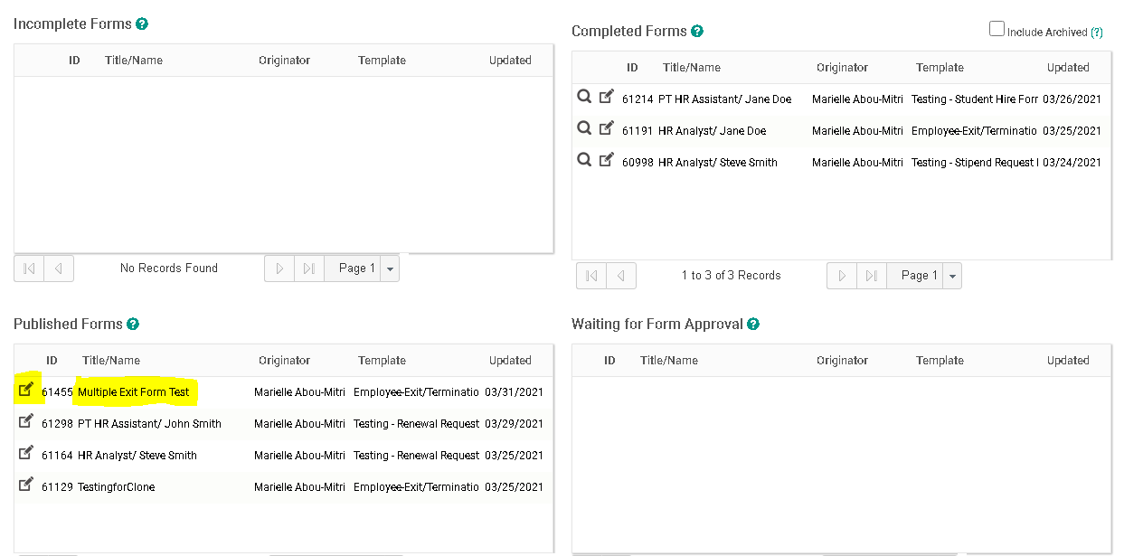
- Click on “Actions” and then click “Copy Data to New Form”.
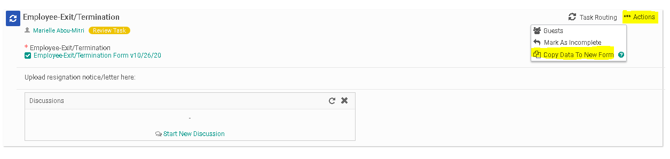
- Fill out the information regarding the new form. Then click “Create Form”.
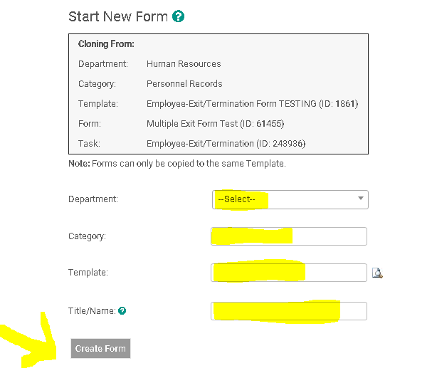
- Click on the form name. When you review the form, all of the information from your original form will be duplicated. Fill out any information that may be different, including “Employee Name”. You will still need to ensure that the Task Routing of the form has identified the correct individuals for approval. After confirming the Task Routing, click “Send for Next Action” to publish.
