Student Employment Handbook
studentemployment@middlesex.mass.edu
Updated: October 2020

Contents

Our Central Purpose 4
Definition of a Student Employee 4
The Basics 5
Student Expectations 5
Supervisor Expectations 5
Work Hours 5
Equal Employment Opportunity 5
Eligibility Requirements 6
Core Enrollment Criteria 6
International Students 6
Student Classifications and Pay Rates 6
Changes in Employment Classification 7
Transitioning to a Part-time or Full-time Professional Position 7
How to Find a Position 8
Search Current Openings 8
Review Job Descriptions and Requirements 8
Apply for a Job 8
Keep Trying 8
What Happens Next? 9
Be Prepared to Interview 9
Payroll Procedures and Related Information 10
Submitting Time Worked 10
Pay Periods Dates (two per month) 10
Direct Deposit 10
Taxes & Deductions 10
Overtime 10
Workplace Injuries 10
General Policy and Procedure 11
Academic Break and Holidays 11
Employment Verification and Unemployment Claims Error! Bookmark not defined.
Enrollment Requirements 11
Meal and Break Policy 11
Sexual Harassment Policy 12
Student Code of Conduct 12
Disciplinary Procedures and Terminations 12
Job Separation in Good Standing 12
Due to Enrollment 12
Voluntary Resignation 12
Expiration of Employment Term 12
Frequent Questions and Situational Guidance 13

Our Central Purpose
At Middlesex Community College (MCC), student employment is seen as a fantastic opportunity for current students to balance the needs of the classroom with the financial needs of pursuing a college degree while furthering their career development. Students employed by MCC are exposed to a professional work environment where they develop many of the important transferrable skills that help college graduates enter the workforce.

MCC is dedicated to helping students set the stage for professional life by supporting growth and development in the following areas:

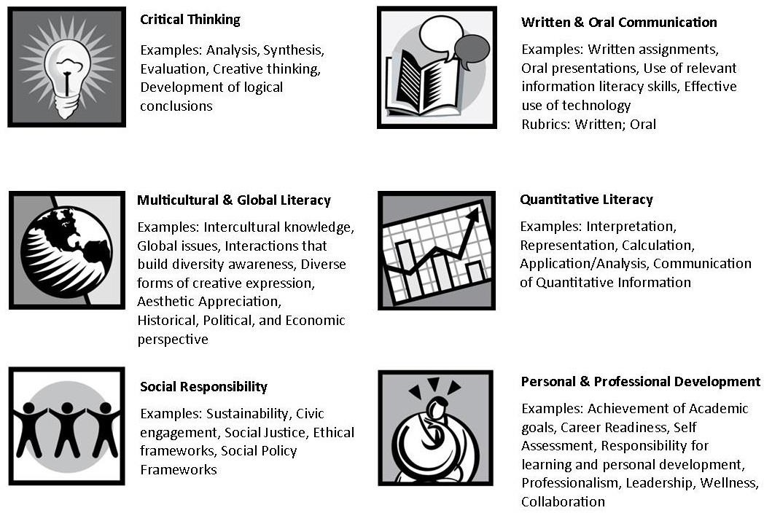

Definition of a Student Employee
A student employee is a part-time employee who is registered for classes and/or matriculated at Middlesex Community College and whose primary purpose for being at the institution is for coursework and/or the achievement of a degree or certification. A student employee retains this classification during brief lapse of enrollment such as between semesters or other reasonable gap (when the student is registered for the upcoming semester).

The Basics

Student Expectations
- Fulfill the duties and responsibilities of the job description
- Maintain professional behavior and representation of the college
- Maintain appropriate confidentiality and avoid conflict of interests
- Work a consistent, reliable schedule
- Dress in a manner appropriate for the work environment
- Comply with department rules and policies
- Do not expect to study or do homework on the job
- Work hours are not to be logged over scheduled class times

Supervisor Expectations
- Follow proper hiring procedures for Student Employment
- Provide student a clear explanation of job duties and expectations
- Provide necessary training and orientation
- Serve as a role model for professional behavior
- Recognize and support the success of student employees
- Follow applicable college policies related to Student Employment

Work Hours
- 7.5 hours per day maximum (must take appropriate breaks)
- 18.5 hours per week maximum during academic term
- No work hours to be logged during scheduled class times

Equal Employment Opportunity
It is the policy of Middlesex Community College to provide equal employment opportunity without regard to race, color, religion, sex, sexual orientation, gender identity and expression, age, national origin, ancestry, genetic information (GINA), disability, or veteran status.

For additional information visit: http://www.mass.edu/shared/documents/affirmativeaction/CCAffirmativeAction.pdf

Eligibility Requirements

Core Enrollment Criteria
- Registered at Middlesex Community College in current or upcoming semester.

International Students
An International Student is permitted to work part-time on the premises of Middlesex Community College, if, among other requirements, the student has active F-1 status, is enrolled full-time, and he/she does not displace a
U.S. resident. If conditionally hired, the student will be provided documentation to secure a work-only Social Security number through the Social Security Administration department and submit to the college’s Human Resources office located in the Cataldo Building on the Bedford campus.

Student Classifications and Pay Rates
All students must be paid hourly at the same base rate for comparable work. The work-study rate determines the minimum base pay for all student jobs. Departments must submit request to Payroll for classification approval and ensure funds have been allocated before posting position.

To ensure equitable pay practices across student positions, grades are based on complexity and responsibilities.

Grade Level | Base Hourly Rate | Description
Grade 1 | $13.00 | Entry-level position that involves routine or repetitious work. Employee is well supervised. No experience required. Responsibilities will require basic knowledge of assigned tasks.
Grade 2 | $14.00 | Requires previous work experience and/or moderate level of competence. Tasks assigned require some degree of responsibility. Responsibilities may include leadership or oversight of a project or area or may involve light supervision of peers. Requirements may include a degree of proficiency in a particular skill area. Independent work is likely. Specific training may be  necessary.
Grade 3 | $15.00 | A high level of competence is expected and tasks require responsibility and independent thinking/judgment. Job may be complex and have additional qualifications. Responsibilities require proficiency in an area of specialized  knowledge or skill. Training is required.

Note: There are no merit or seniority based pay increases through the Student Employment program (Ex. Students in Grade 1 roles who wish to earn more must seek employment in a Grade 2 or 3 role).

Changes in Employment Classification

Transitioning to a Part-time or Full-time Professional Position
Holding a student employment position with MCC is a great opportunity, and students often inquire about their chances of obtaining more permanent employment with the college. In a few cases each year, exceptional student employees apply and are hired for more permanent forms of employment with the college. Our advice to any student hoping for this outcome is to view their student position as an extended internship/interview and a prime opportunity to show their professional potential.

MCC does not, however, have a promotion system for student employees or special process for internal applicants, and any opening with the college is publicly posted at www.middlesex.mass.edu/studentemployment. Students that apply for open positions will be held to the same processes and applicant requirements as the general public.

Students accepting advanced positions should understand that in doing so they have fundamentally altered their predominant relationship with the college from that of a “student” to that of an “employee.” That shift brings with it increased professional expectations, changes in the taxing of earnings (see page 12), and the end of the
individual’s eligibility for any student employment positions while employed as a permanent employee. These changes, of course, may be worth the many personal and professional benefits that come with working for MCC on a permanent basis.

Note: Students cannot hold a Student Employment Position and a Work-Study Position at the same time

How to Find a Position

Search Current Openings
  - Student positions are posted on Handshake.

Review Job Descriptions and Requirements
  - Only apply for positions for which you are qualified and genuinely interested
  - Carefully read the duties, responsibilities, and preferred qualifications
  - Read the special instructions of each description for any additional steps that may be required to process your application

Apply for a Job
    - To apply, all on-campus jobs are posted on Handshake. You can access Handshake by going logging into you “MyMCC”. On the left side of the page is the “MyCareerPathTools”, click the link and you will be brought to all the career tools. Click the Handshake link and you will be brought in.
    - All students applying for on-campus non-work study jobs at Middlesex Community College are required to submit a professional resume and cover letter. If you’re a MCC student applying for a job and need assistance with creating or reviewing your resume and cover letter prior to applying please email StudentEmployment@middlesex.mass.edu. After submitting an application you will receive a follow-up email by Genevieve Morse, career counselor and student employment coordinator with various resources, welcome video and professional development opportunities.
    - See our in-depth how-to for more information about applying at www.middlesex.mass.edu/studentemployment

Keep Trying
Student jobs are in high demand, and eligibility for student employment does not guarantee a position. Open positions go quickly, so keep checking the online postings. You might not find your dream job, and you may even need to consider off-campus employment.

Please see the end of this handbook for Student Guide with instructions on how to search for jobs and upload your documents.

What Happens Next?
If selected for hire following an interview, students should go to the payroll office to complete:
  - Job Assignment Form
  - Direct Deposit Form
  - Confidentiality Statement
  - W4
  - I-9 Employment Verification
  - Photo Release Form

Be Prepared to Interview
If selected for an interview, you will be contacted directly by the hiring department. Please understand that the process of reviewing applicants may take upwards of 2 or 3 weeks for some positions.

Questions you may be asked in an interview:
    - Tell me a bit about yourself.
    - Why are you interested in this position?
    - What skills or experience do you have that will help you be successful here?
    - What is your schedule availability?

Tips for interviewing:
    - Show up on time (i.e. 5-10 minutes early)
    - Dress appropriately (business casual)
    - Stay positive, speak in a clear and confident voice, look people in the eye
    - Be polite and courteous to all staff and visitors
    - If you cannot make it to your scheduled interview due to an emergency, call to apologize and reschedule in advance or as soon as possible

Note: Only Some positions require interviews. Some positions also require special qualifications and or training prior to starting. These trainings are unpaid.

Payroll Procedures and Related Information

Submitting Time Worked
Student employees enter work hours electronically using a timesheet given to them via their supervisor. These
timesheets are the student’s responsibility to fill out and timesheets that are late or unsubmitted will delay or void a paycheck to the student.

Please report your hours in 15 minute (1/4 hour) increments of time. For example, your hours worked could be 11:15am-2:30pm. If you work more than 6.25 hours in a day, one-half of an hour will be deducted from your hours to take into account a half-hour break.

Pay Periods Dates (two per month)

Pay period | Time Due Date | Pay Day
1st through 15th | 16th of each month | Last day of month
16th through last day | 1st of next month | 15th of next month

Direct Deposit
If being hired through Student Employment, direct deposit is a requirement.

Physical paychecks may still be required as direct deposit is in process or for other reasons. They are available for pick up on the appropriate pay day at the Payroll Office, located in the Cataldo Building on the Bedford Campus. Students will need a valid photo ID. The Payroll Office is open between the hours of 9:00am and 4:00pm. Monday through Friday only.

Taxes & Deductions
Taxes: Wages earned through any student employment position are considered taxable earnings and subject to applicable Federal, State, and local tax procedures. Student employees complete appropriate tax forms at the point of hire. To update personal withholdings, address, marital status, or any other tax information, contact the Payroll Office located in the Cataldo Building on the Bedford Campus.

Deductions: Additional deductions may be applied as required or desired by the student, including: wage garnishments or additional tax contributions.

Overtime
The maximum hours a student employee may work is 18.5 per week. With this in mind, no student employee should accrue overtime wages. No additional hours or wage will be given over 18.5 hours.

Workplace Injuries
In the event of a workplace injury, follow these steps as soon as possible:

- Seek medical attention as soon as possible. If emergency medical assistance is needed, dial 911.
- Notify your MCC supervisor as soon as possible.
- The MCC Human Resources Department will be notified by your supervisor to report the incident/injury.

General Policy and Procedure
For a full list of college policies and procedures, please see the MCC Student Handbook located here: https://www.middlesex.mass.edu/studenthandbook

Academic Break and Holidays
Students should check with their department supervisor in advance to determine if work over the break will be required or needed. Time off over the break is not guaranteed and should be requested officially by following department procedures in advance. Student employees do not receive holiday pay.

Student employment is a form of work or service that is EXCLUDED from unemployment compensation. Any unemployment claims received by the college for positions that were classified as Student Employment will be returned with an indication that the employment falls under the exclusion.

Enrollment Requirements
Student Employment students must be registered for the current or upcoming semester at MCC. If it is determined a student employee no longer meets the enrollment criteria, the student employee will be separated from their position (administrative/system errors regarding the student’s enrollment may be taken into consideration if needed).

During the summer term, Student Employment students may work without enrollment under the condition that they were working and eligible during the prior spring term.

The Computer/Network Usage policy
Please refer here for MCC’s computer/network Usage policy:

http://catalog.middlesex.mass.edu/content.php?catoid=18&navoid=1668&hl=computer+network+usage&returnt o=search#Computer Network_Usage_Policy

Meal and Break Policy
Massachusetts law states that employees are entitled to a 30-minute meal break when working a period of more than 6 consecutive hours. During this break, an employee must be relieved of all duties and must be free to leave the workplace. This break period may be unpaid. Exemptions from the meal break requirement can be found
in M.G.L. c. 149, s. 101.

An employee may voluntarily give up a meal break by (1) working through his or her meal break, or (2) remaining on the premises during the break at the request of the employer. However, the employee must be paid for this time.

Employees are allowed to pray during their meal break. The meal break is considered the employee's free time.

Sexual Harassment Policy
Please refer here for MCC’s sexual harassment policy:

https://www.middlesex.mass.edu/humanresources/downloads/sexharr2014.pdf

Student Code of Conduct
Student employees are held to the standards of the Student Code of Conduct, available to view at https://www.middlesex.mass.edu/studenthandbook. Students found to have broken the code of conduct will be reported to the Assistant Dean of Students and may be terminated from their position.

Disciplinary Procedures and Terminations
Student employees are at-will employees of the college, and MCC reserves the right to terminate a student employee with or without notice. This includes situations brought on by lack of funding, lack of available work, or general discretion of the department supervisor.

Issues with performance and/or conduct are handled between the student and hiring department. A progressive model of discipline that models a professional work environment is suggested for departments to use.

Students may be temporarily suspended for evidence of: continued unexcused absences, insubordination, and misuse of college property, possession or use of drugs and/or alcohol on college property, theft, or timesheet falsification. Students will be referred to the conduct process. Official criminal charges against the student employee in these and other situations may be filed with the MCC Public Safety.

When terminating a student employee, departments will communicate the termination date, grounds for termination, and any supporting documents to the student in question.

In situations where a student’s grounds for termination violated the Student Code of Conduct, any potential future employment with MCC will not be authorized until the student has completed any steps adjudicated by the conduct process and the Assistant Dean of Students.

Job Separation in Good Standing

Due to Enrollment
When a student fails to meet the stated enrollment requirements, he/she is removed from their position. This removal is considered in good standing, and the individual would be welcome to apply in the future when he/she once again meets the enrollment and all other eligibility requirements for Student Employment.

Voluntary Resignation
A two week advanced notice is preferred for any student employee wishing to resign from their position. Failure to provide proper notice is considered poor form in the professional world. If switching positions on-campus, it is recommended that a proper two week notice be provided to the current employer before authorizing the hire for the new position.

Expiration of Employment Term
All student employment positions are temporary positions with the college that expire at the end of each academic semester. If a student is no longer eligible for employment or is not rehired for their position beyond the final day of the academic year, the employment will be ended.

Frequent Questions and Situational Guidance

Issue | First Option | Second Option (if needed)
Schedule Requests | Speak directly with your supervisor, and provide as much notice as possible. Only adjust your schedule if necessary.
Taking Time Off Over Break | Look ahead at each semester schedule to determine when breaks are. Notify supervisor as soon as possible to discuss if you will be working, or if you do not plan  to.
Problems With Pay Check | Confirm with supervisor when/if timecard  was submitted. | Payroll Office, Cataldo Building Bedford  Campus
Problems With Email or Computer Account | IT Support Center: Email: servicedesk@middlesex.mass.edu Phone: 3301  Office: 4th Floor Cowan Center, Lowell  Campus
Employment Verification | Human Resources, Cataldo Building  Bedford Campus | Student Development Office, Enrollment  Center Bedford Campus
W-2s | Payroll Office, Cataldo Building Bedford  Campus
Accessing Timecards and Pay  Stubs | Payroll Office, Cataldo Building Bedford  Campus
Conflicts With Fellow Employees | Try to work out issues directly with co- worker. In a calm, professional manner, discuss the issue in a private space, not where other students and staff will  overhear. | If needed, speak with your supervisor about the conflict. They may be able to assist in conflict resolution.
Harassment Complaints | Directly inform the person engaging in harassing conduct that such conduct is offensive and must stop. | If harassment continues, contact your supervisor, the Equal Employment Opportunity (EEO) Officer in Human Resources, or Public Safety (when  appropriate).
Sexual Harassment Complaints | Contact the Equal Employment Opportunity (EEO) Officer in Human Resources, or Public Safety (when  appropriate). | Supervisor will inform Equal Employment Opportunity (EEO) Officer even if students wish to remain anonymous.
Reporting Resignations | Speak directly with supervisor and then provide a written notice that you will no longer be working and when your last day of work will be (email is okay). This means you work the remaining time after submitting your resignation until what you’ve stated is your last day (two weeks  is standard).

