Interview Exchange Step-by-Step Guide for Task Routers
This training guide will assist you in approving/ reviewing/editing a form in the Interview Exchange Forms Module. Please note, once the task is published/triggered, all task assignees will receive an email notifying them to complete the task. You may access the form requiring approval by following the steps below or through the link provided to you in the email you receive from Interview Exchange.
- After signing into Interview Exchange, click on the Interview Exchange Forms Module:
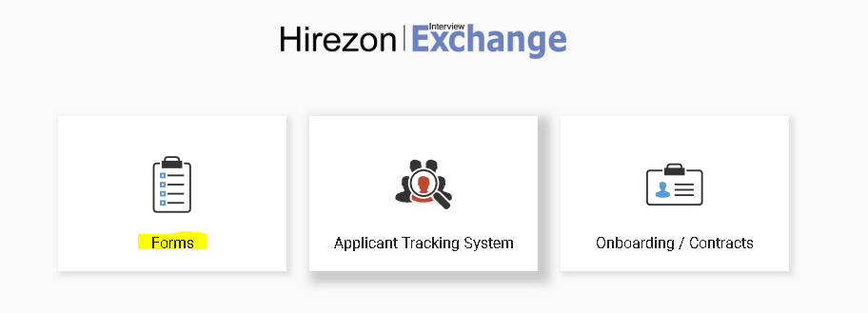
- This screen is called your “Dashboard”. This is where you will see all the forms that are assigned to you for approval/review in the task routing. Click on the number next to the heading titled, “Assigned to me”.
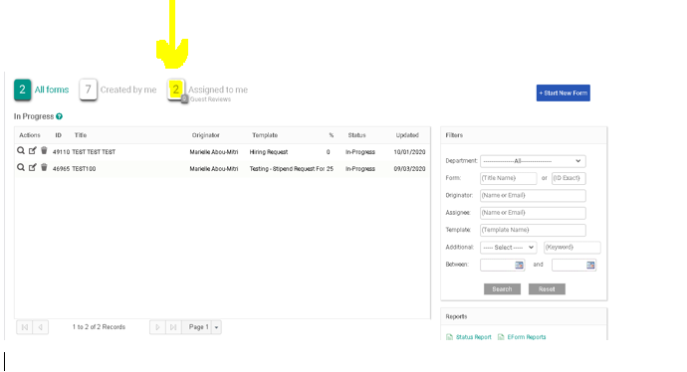
- Any forms awaiting your approval will be listed under the “Waiting for Task Approval” heading. Click on the “Edit” icon to the left hand side of the form’s name to begin the process.
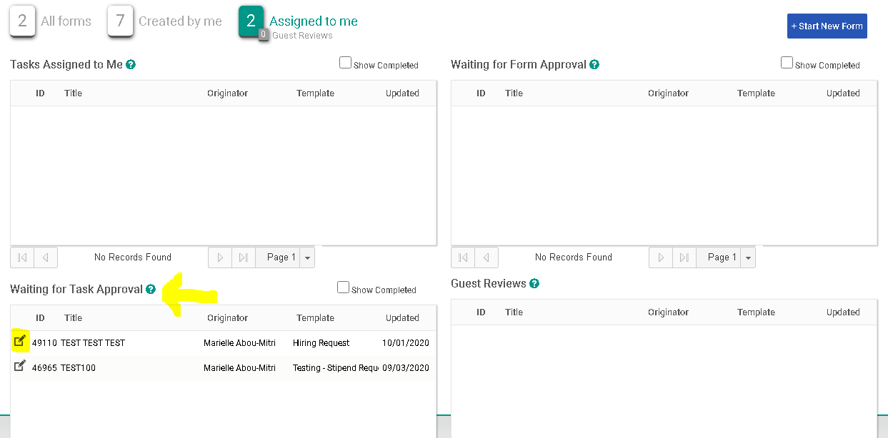
- Click on the name of the form to begin the approval process. In the below example, the “Hiring Request Form” is the form requiring approval.

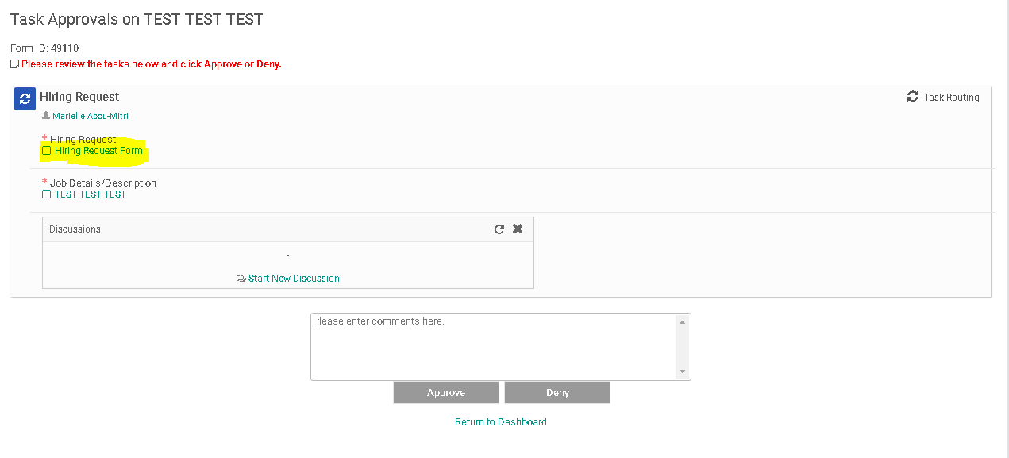
- Review the contents of the form and make any necessary changes. Please note, you will only be able to make changes to the form if you were given these permissions at the time the form was created. Click “Save & Submit” once you are ready to proceed.
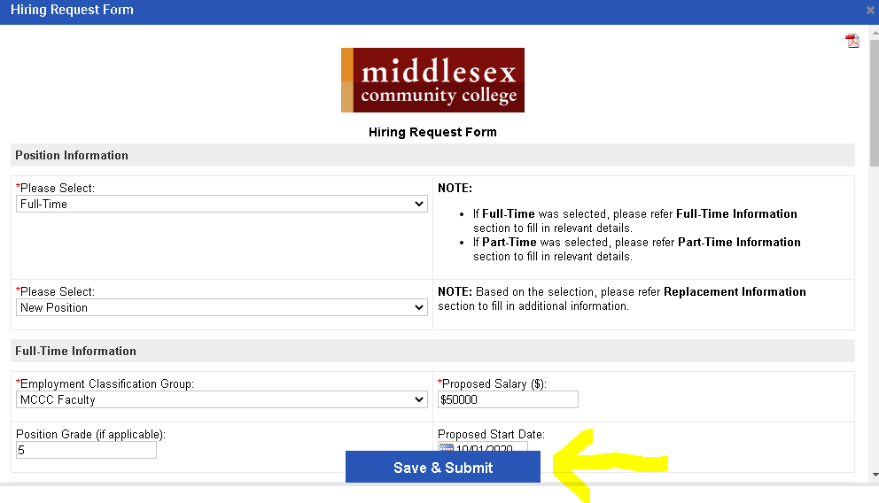
- Review the document again and press “Continue”. You may also go back to the “Edit” screen if you need to make any additional changes.
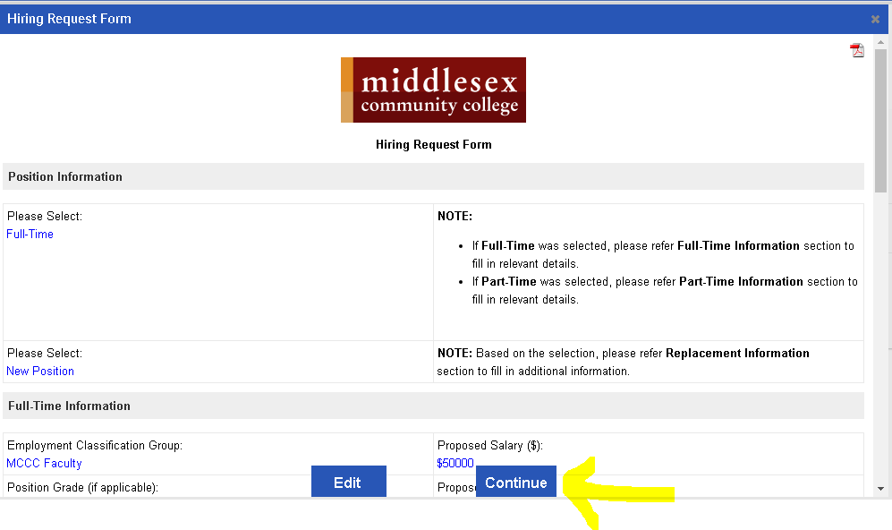
- A small check mark will appear to the left of the form that you have approved. In the below example, a “Job Details/Description” also requires review and approval.
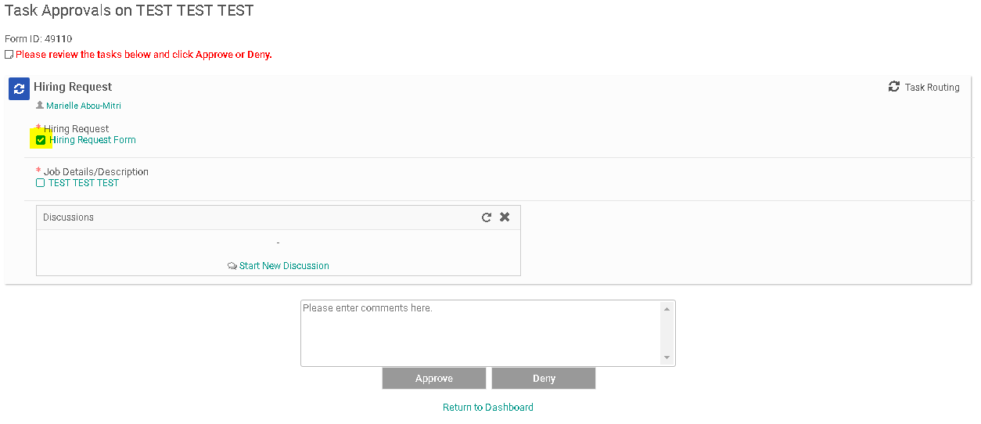
- Click on the name of the second section to continue with the approval process. In the below example, the name of the “Job Details/Description” requiring approval is “TEST TEST TEST”.
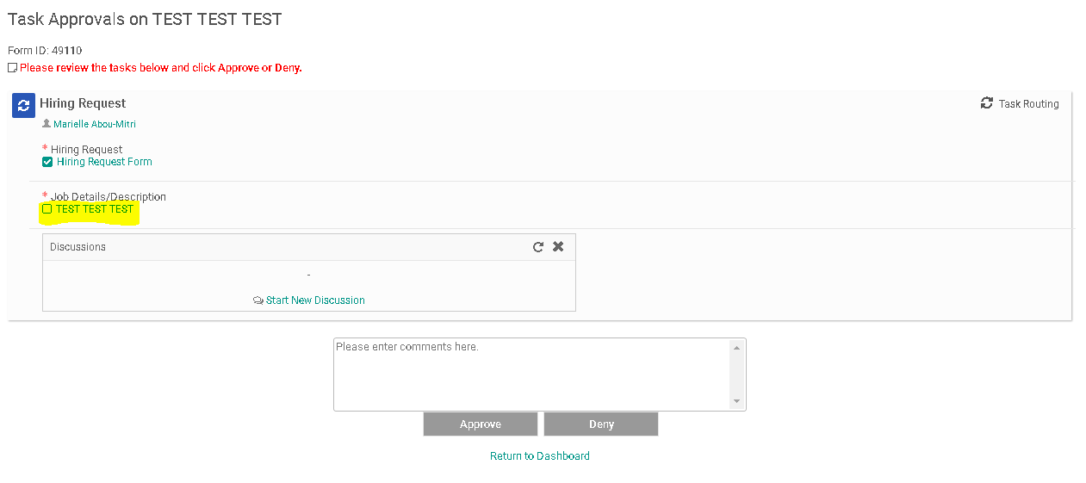
- Review/Edit the job description and click on “Save Job Details”.
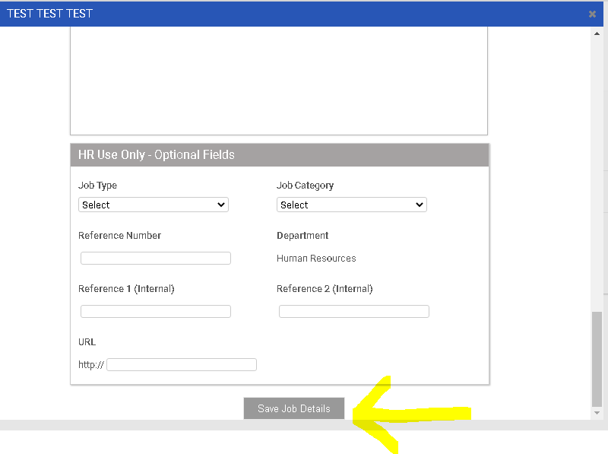
- Review the document again and press “Close”. You may also go back to the “Edit” screen if you need to make any additional changes.
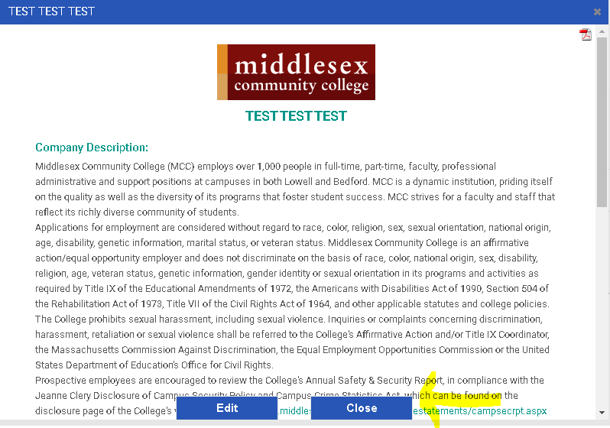
- Once all the forms/documents have been reviewed a small check mark will appear to the left of the form/document name. To proceed, click “Approve” or “Deny”.
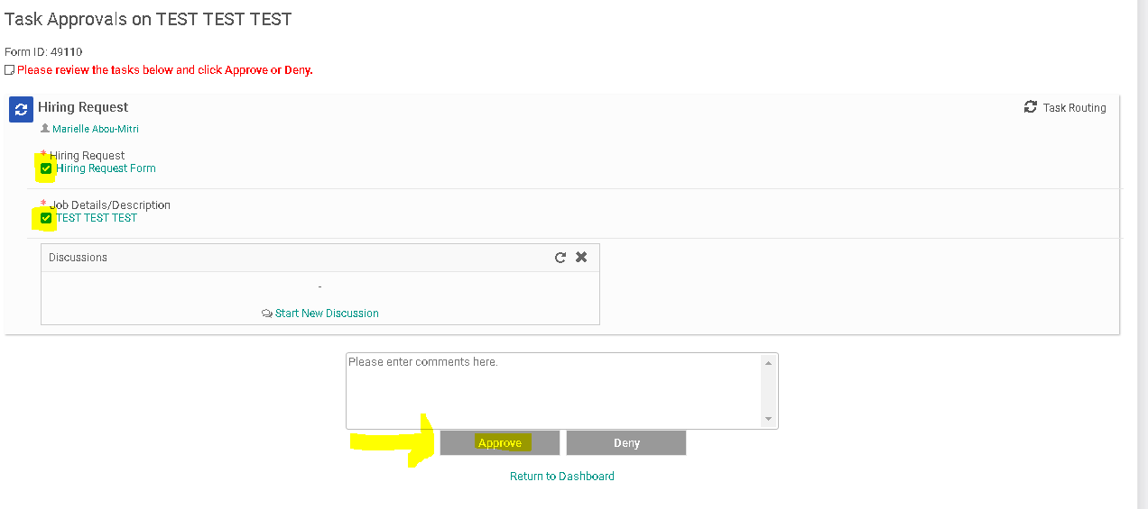
- You will receive an alert at the bottom of the screen once you have successfully approved the form.
