Interview Exchange Step by Step Guide for Cloning the Workflow when Issuing Stipends to Multiple Recipients
This guide will assist hiring managers when issuing a stipend to multiple recipients. The hiring manager generating the Stipend Request Form will be able to issue multiple employment contracts within the same workflow without having to issue multiple stipend request forms.
The Interview Exchange Step by Step Guide for Stipend Request Form should be reviewed first, then follow the steps below.
- On the existing Stipend Request Form, after the Stipend Request Form has been filled out and the Task Routing for the Stipend Request Form has been entered, under the Employment Contract heading click on “***Actions” “Clone Workflow”. This will create a copy of the task workflow of the Employment Contract. Please note: The workflow will need to be cloned for the same amount of stipend recipients i.e. if you are issuing stipends to 3 employees, 3 employment contracts will need to be cloned and issued, etc.
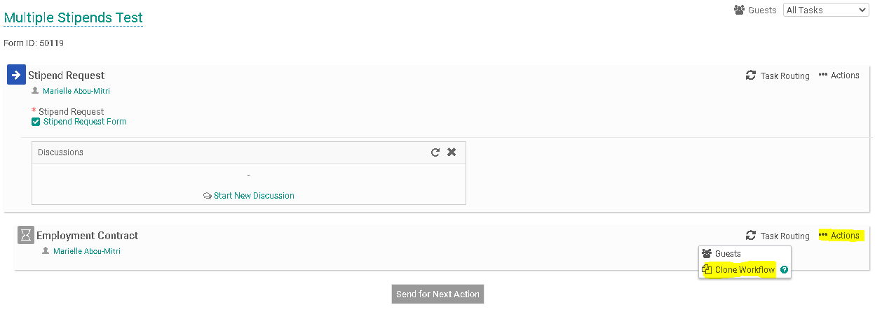
- You will now see two Employment Contracts listed in the workflow. Each employment contract will need to be assigned to the corresponding employee receiving the stipend. 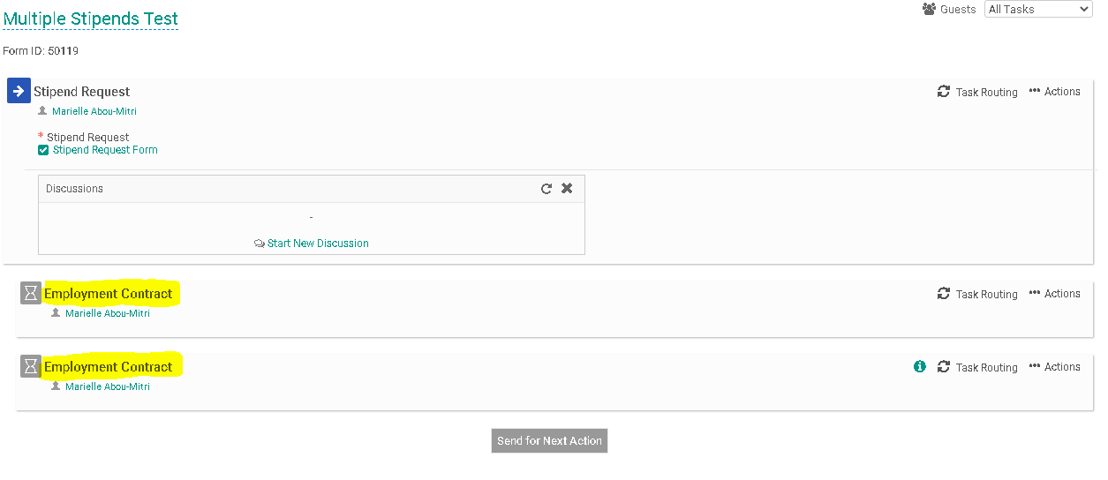

- Click on the “Task Routing” associated with the first Employment Contract.
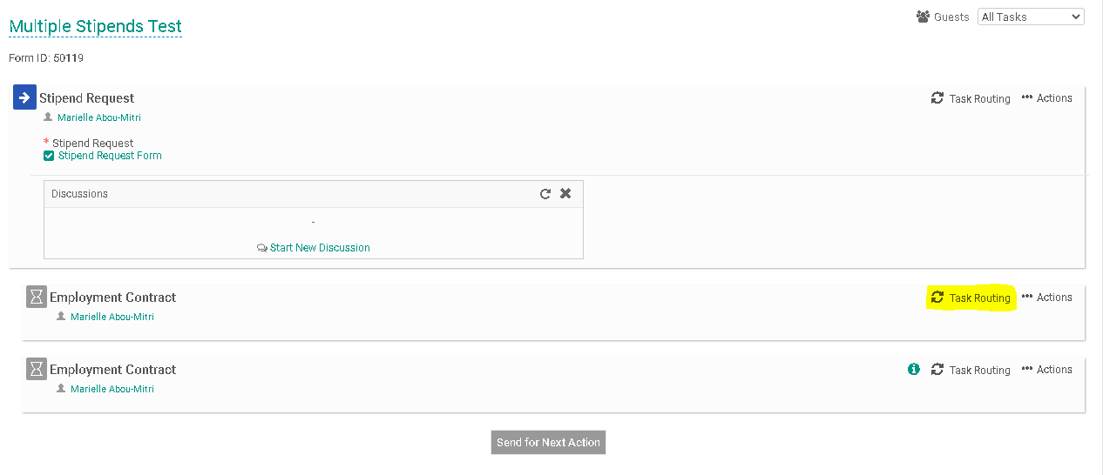
- Click on the Edit Routing User Icon (highlighted below) alongside the Employee to enter a name for this field.
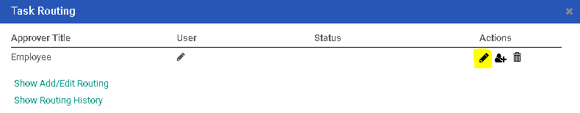
- Enter the Employee’s name into the “User” field. As you type this person’s name, the system will recognize people with accounts in the system and will prepopulate the field. You may search by first or last name. Click “Save Routing” once you have entered the field.
-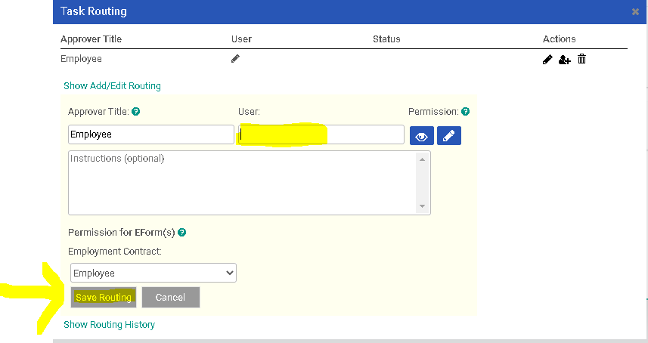
- Repeat steps 3-5 above for the task routing associated with any other employment contracts you are issuing. You will need to assign the task routing to other employees receiving the stipend.
- Click on “Send for Next Action” to initiate the Stipend Request Form and begin the task routing process.
