Interview Exchange Step-by-Step Guide for Stipend Request Form
The Stipend Request Form is used to issue payment to a current employee, generally a faculty member, for work completed outside an employee’s general job duties. Previously, these payments were issued via JAF. Once the Stipend Request Form is generated and approved by the task approvers, the Hiring Manager generates an Employment Contract to the employee.

- After signing into Interview Exchange, click on the Interview Exchange Forms Module:
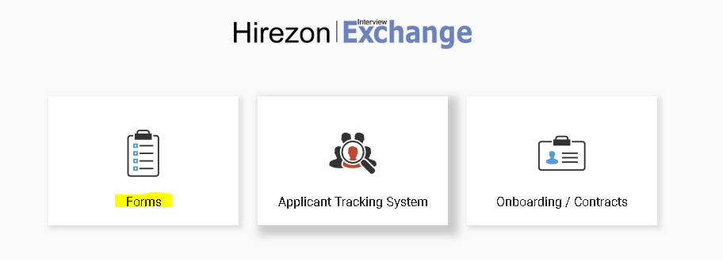

- This screen is called your “Dashboard”. This is where you will see all forms that you’ve completed or are still pending. Click on “Start New Form”.
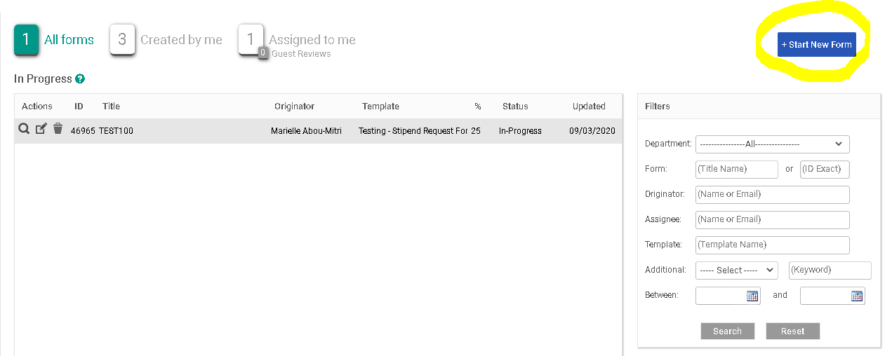
- The next screen is the “Start New Form” screen.
  - You will be required to select the correct department from the Department dropdown list. Note: You will not be able to change the department once the form is created.
  - Select the corresponding category from the Category (Personnel) dropdown.
  - Select the required template from the Template (Stipend Request Form) dropdown. Once the template is selected, you can preview the template by clicking the magnifying glass icon.
  - Enter a Position Title/Name in the Title/Name field.
  - Click Create Form.
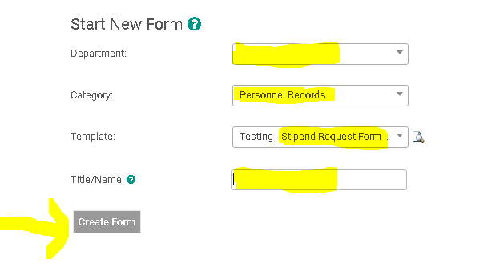
- After you click on “Create Form” you will be directed to the following page to complete a series of tasks. Click on “Stipend Request Form”.
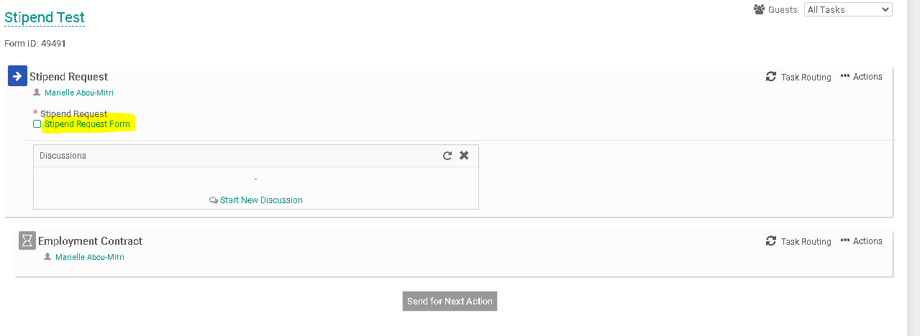
- Fill out the specific information in the required fields regarding the stipend you are issuing. If the same stipend is being issued to more than one employee, indicate so by choosing “yes” to the question, “Will this stipend be issued to multiple recipients?” When you have finished filling out the form click, “Save & Submit”.
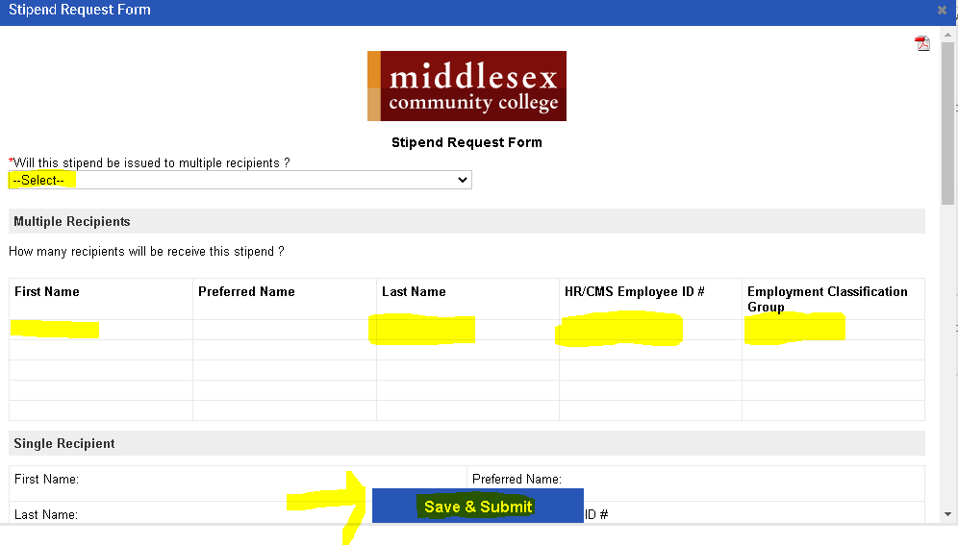
- You will then be prompted to review the information you submitted on the form. You can click “Edit” if you would like to make changes. Otherwise, click “Continue”
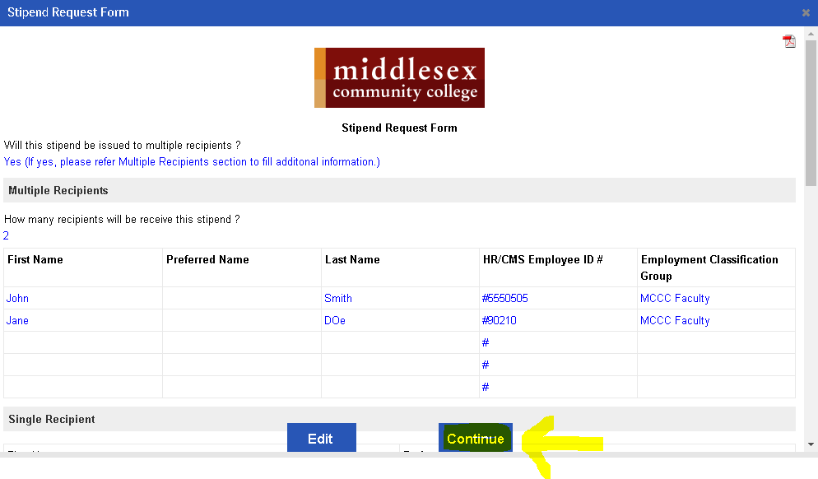
- Your screen should now indicate a small check mark in front of the “Stipend Request Form” to indicate that you’ve completed this task.
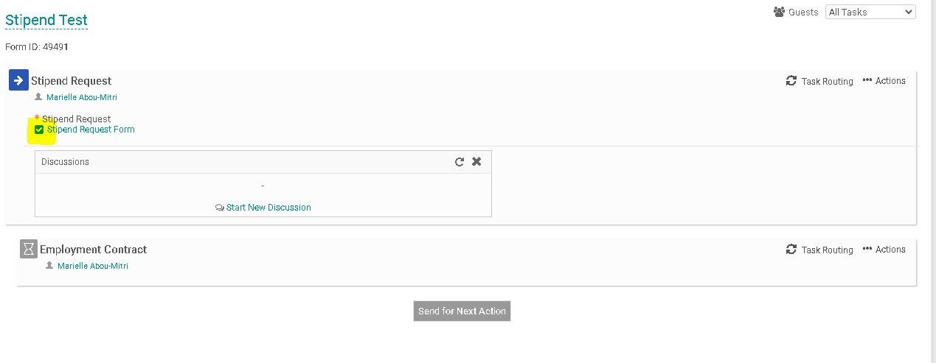

- Your next step will be to generate the Task Routing process so all parties involved may approve your Stipend Request Form. Click on “Task Routing” to begin this process.
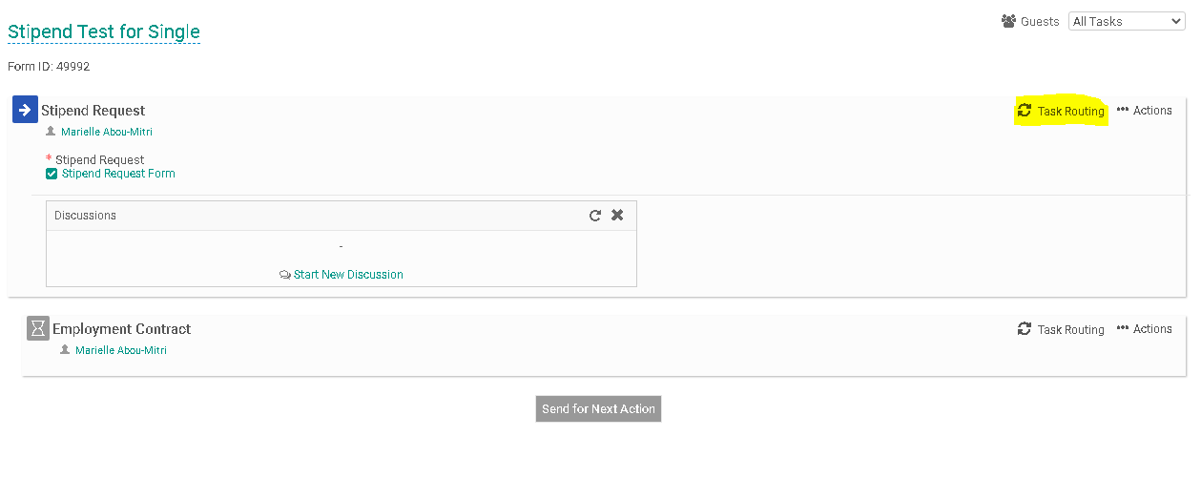
- Certain people in the task routing screen are prepopulated. On the Stipend Request Form, the Human Resources and Finance representatives are prepopulated. The person filling out the Stipend Request Form will be required to enter a name for the “Hiring/Cost Center Manager” and the “Senior Leader/Cabinet Representative”. Click on the Edit Routing User Icon (highlighted below) alongside the Hiring/Cost Center Manager to enter a name for this field.
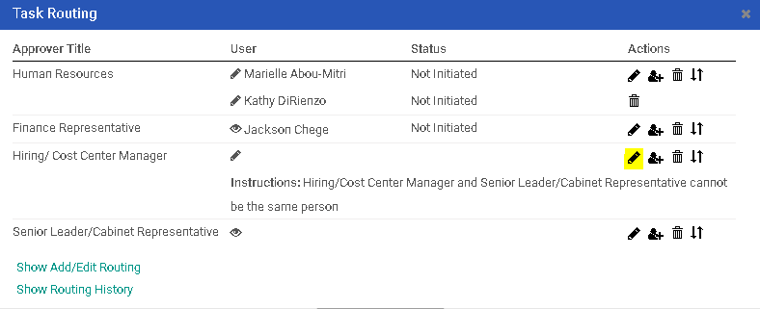
- Enter the Hiring/Cost Center Manager into the “User” field. As you type this person’s name, the system will recognize people with accounts in the system and will prepopulate the field. You may search for the employee using the employee’s first or last name. Click “Save Routing” once you have entered the field.
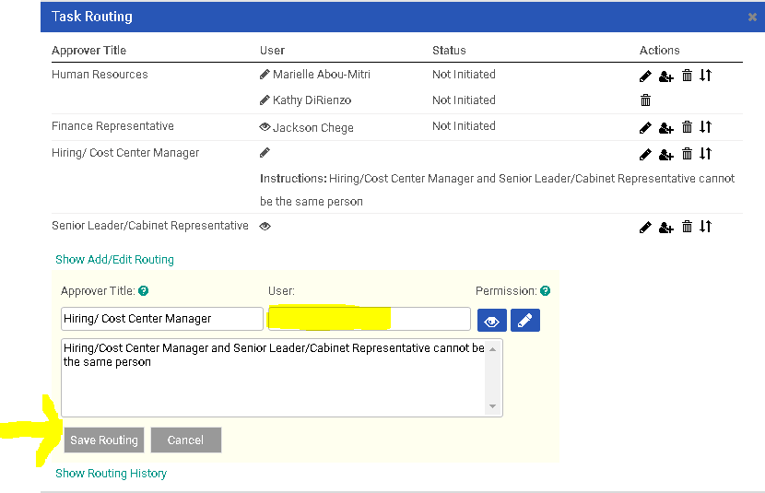
- You will be required to complete the same action for the Senior Leader/Cabinet Representative. Click on the Edit Routing User Icon (highlighted below) alongside the Senior Leader/Cabinet Representative to enter a name for this field.
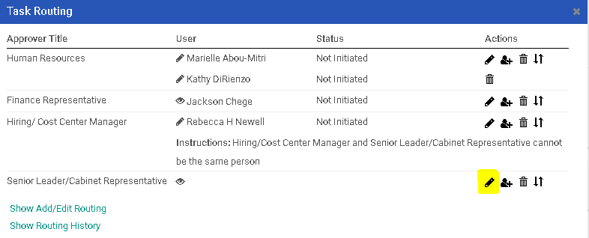
- Enter the Senior Leader/ Cabinet Representative into the “User” field. As you type this person’s name, the system will recognize people with accounts in the system and will prepopulate the field. You may search for the employee using the employee’s first or last name. Click “Save Routing” once you have entered the field.
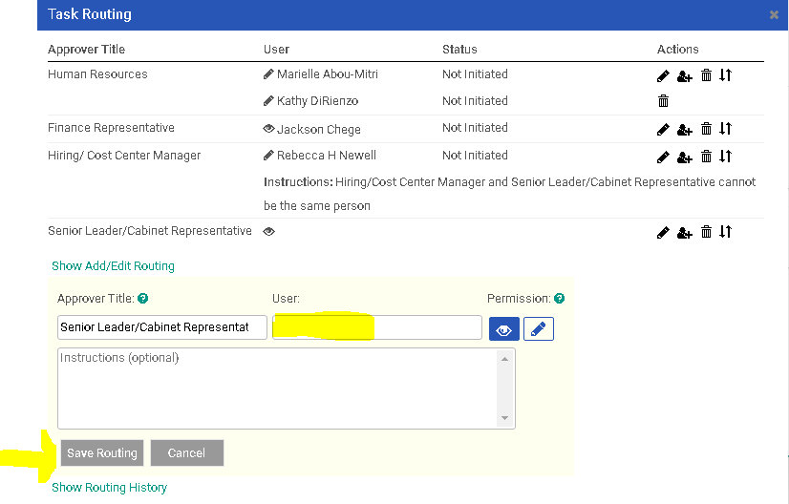
- The employee receiving the Stipend Request will also need to be added to the task routing. Click on the “Task Routing” field to the right of the “Employment Contract” category.
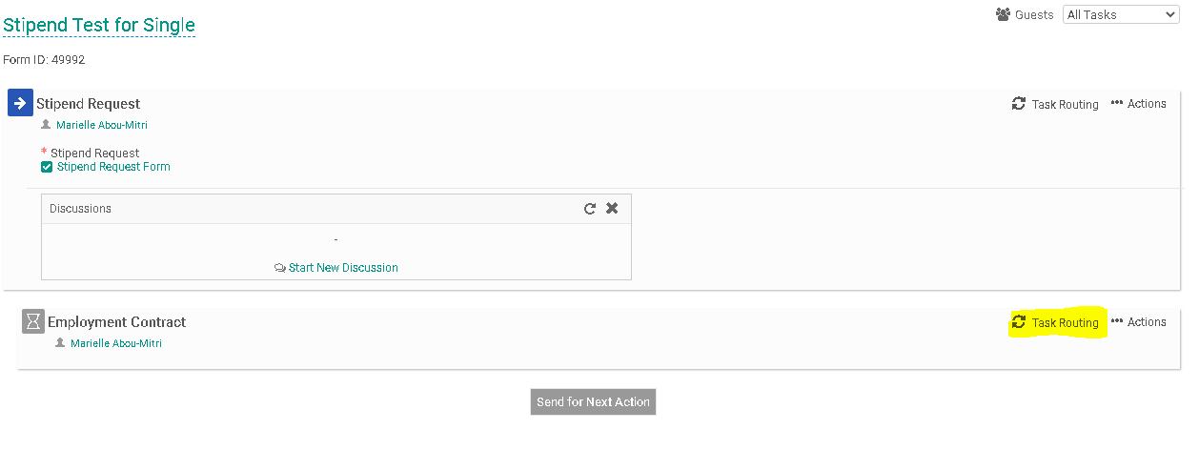
- Click on the Edit Routing User Icon (highlighted below) alongside the Employee to enter a name for this field.
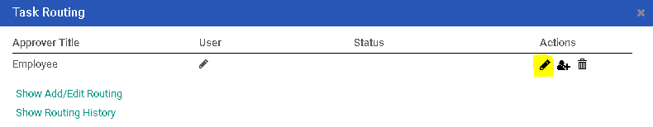
- Enter the Employee’s name into the “User” field. As you type this person’s name, the system will recognize people with accounts in the system and will prepopulate the field. You may search for the employee using the employee’s first or last name. Click “Save Routing” once you have entered the field.
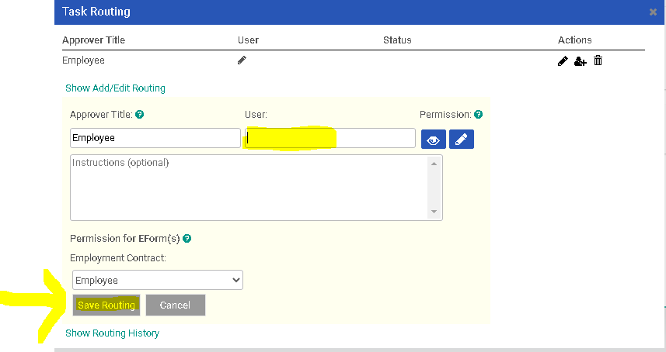
- If you are generating a stipend request for more than one employee, please review Interview Exchange Step by Step Guide for Cloning the Workflow when Issuing Stipends to Multiple Recipients.

- Next, you will need to click on “Send for Next Action”. This will allow for each person in the task routing field to review the Hiring Request Form and approve/deny/edit it. Each person in the task routing field receives an email notification when it is their turn to review the form.
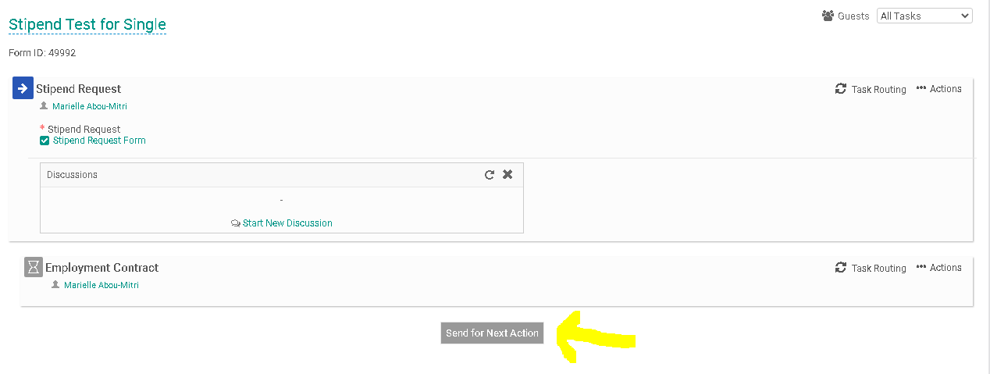
- If you are one of the approvers in the Task Routing of the form, please review the Interview Exchange Step-by-Step Guide for Task Routers.
- Once the Stipend Request Form has been approved by all of the task routers, the Hiring/Cost Center Manager will receive an email notification to complete the Employment Contract. Return to your dashboard under the Forms Module and click on the number to the left of the “Assigned to me” heading. Then click on the “Edit” icon that corresponds to the Stipend Request form you need to complete.
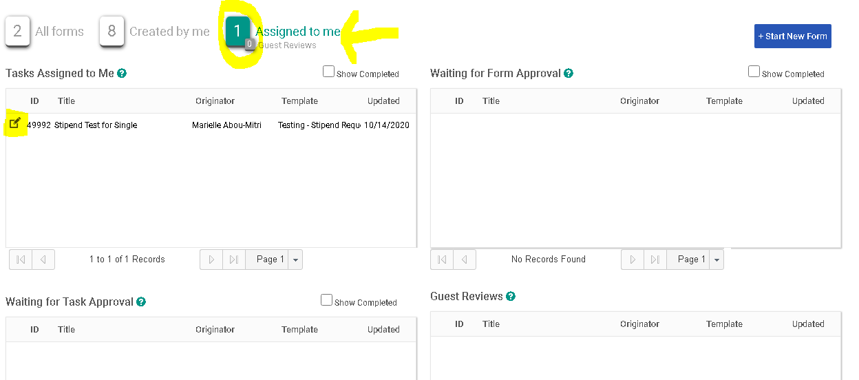
- Click on “Employment Contract”. This will allow you to access the employment contract which will be sent directly to the employee receiving the Stipend Request Form.
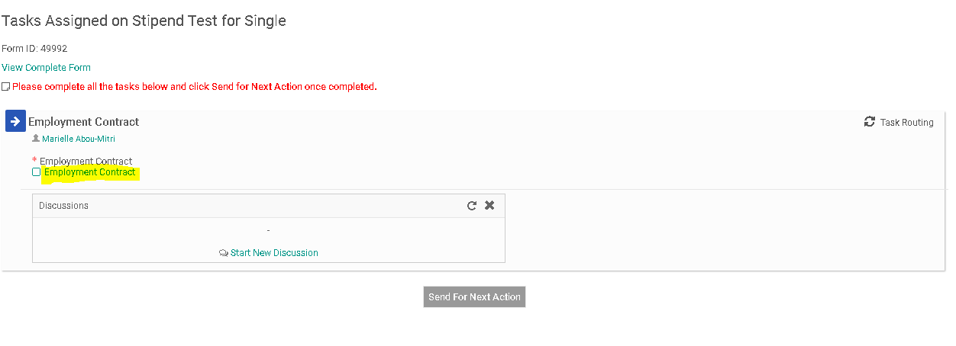
- Enter the information into the required fields. All of the information provided on the Employment Contract should be the same as the information that was previously submitted on the Stipend Request Form. Click “Save & Submit” once you are done.
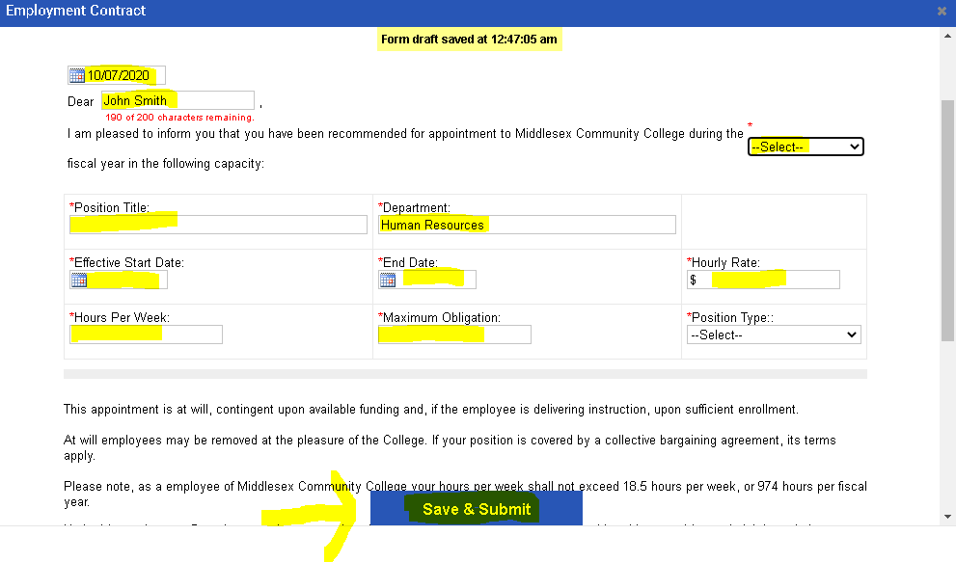
- Review the information you submitted on the Employment Contract and press “Edit” if you wish to make more changes or “Continue” if you are done.
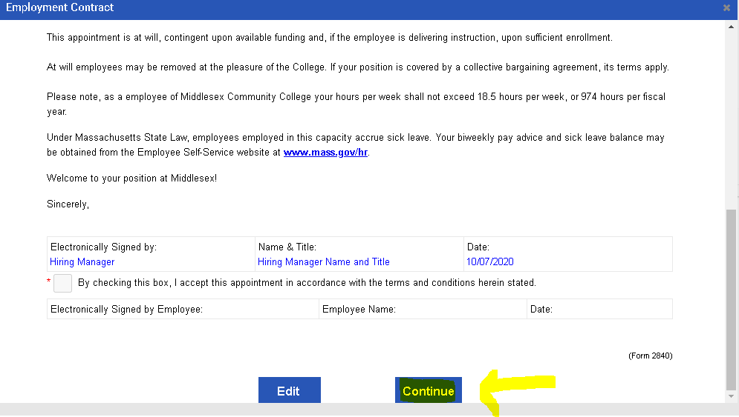

- You will now see a small check mark to the left of the Employment Contract. This means that you’ve completed this task. Click on “Send for Next Action”. Please note: If you submitted a Stipend Request Form for multiple recipients you will have to submit a separate Employment Contract for each individual employee being issued the stipend. You will have to complete steps #20-22 above for each employee receiving a stipend.
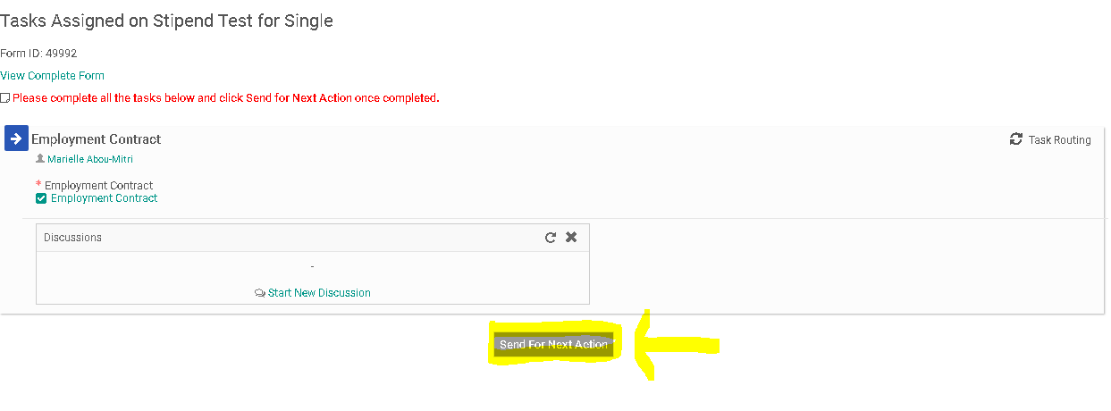
- The employee receiving the Employment Contract will now be issued an email notification informing them about the Employment Contract.

