Interview Exchange Step-by-Step Guide for New Hire Final Recommendations
Once the search committee has met and decided on a final candidate to recommend for hire, the recommendation should be submitted through the IE system.
- After signing into Interview Exchange, click on the Interview Exchange Applicant Tracking System Module:
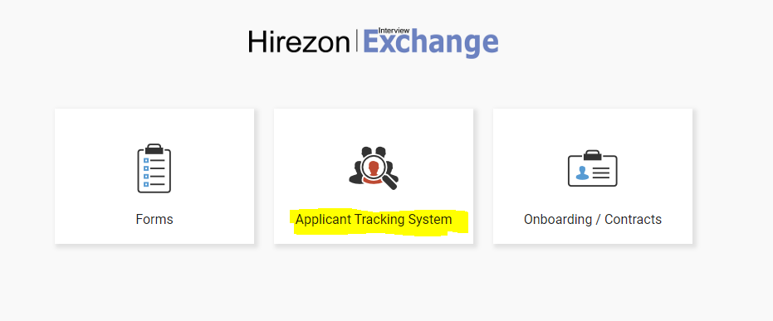
- Click on “Closed Jobs” to view the posting you are hiring a candidate for.

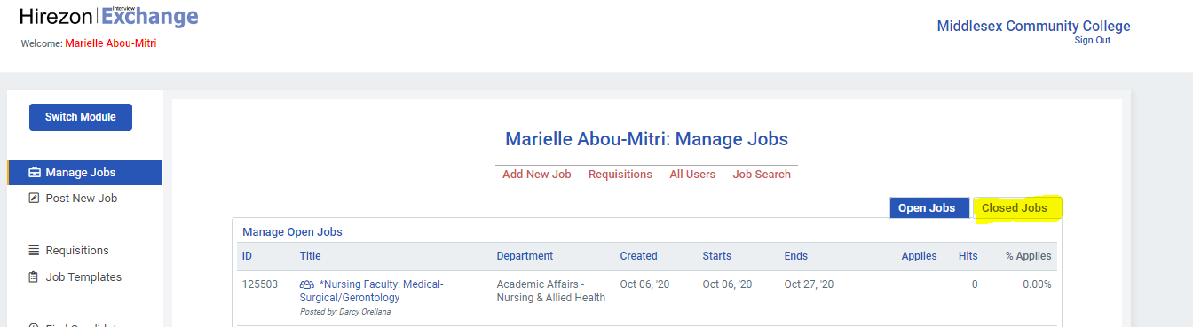
- Click on the name of the job title.
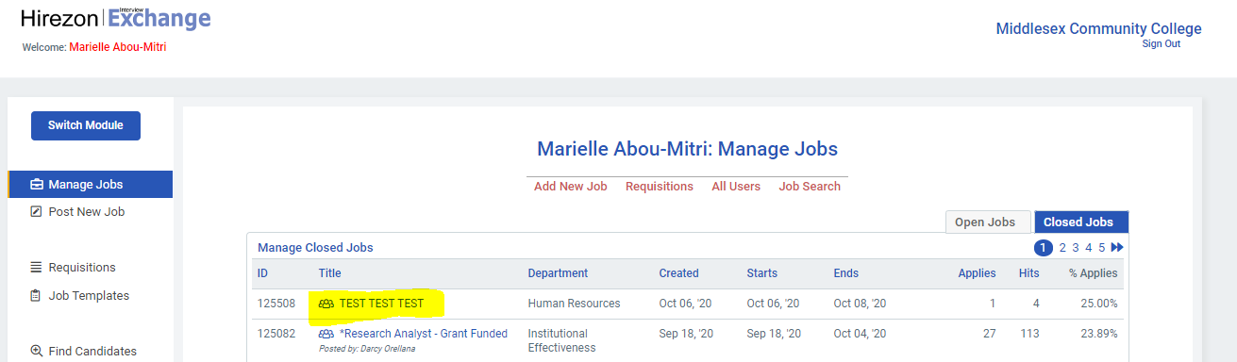
- Scroll down to the “Folders” option and click on “All Folders” on the left hand side.
- Click on the name of the candidate you are recommending for hire.
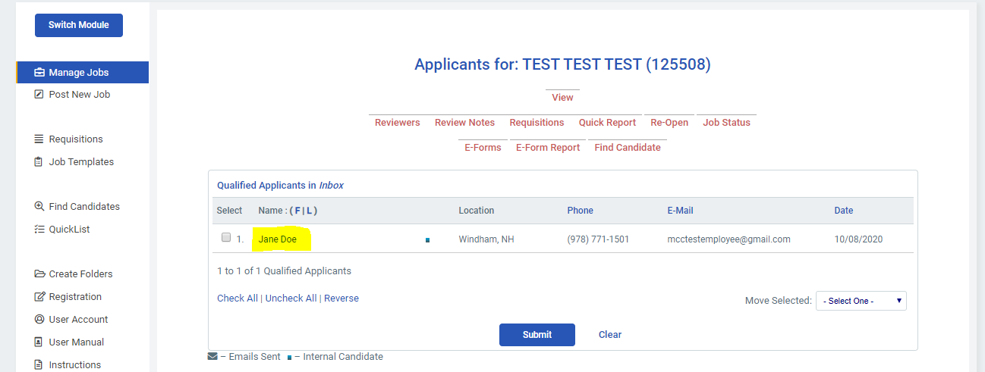
- On the right side of the candidate’s profile click on the job title of the position.

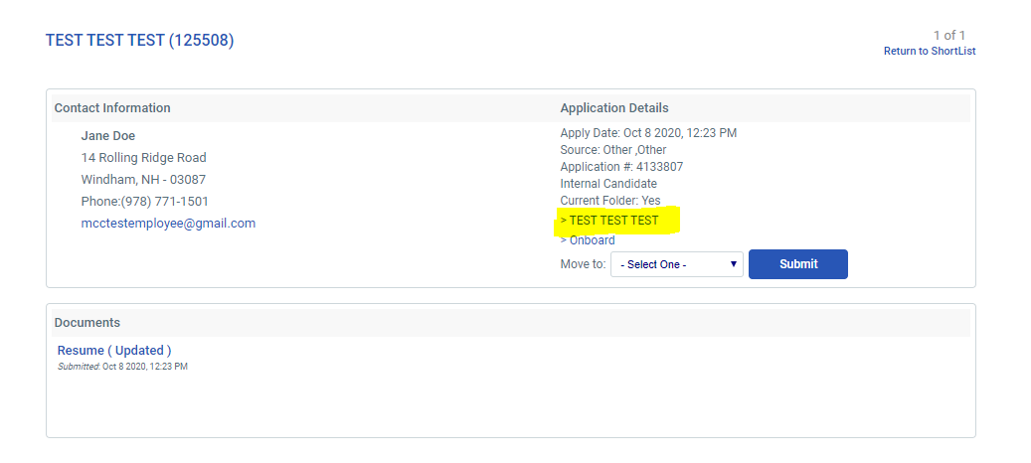
- You will be asked to generate a new form. On this screen, click on “Show existing forms”.
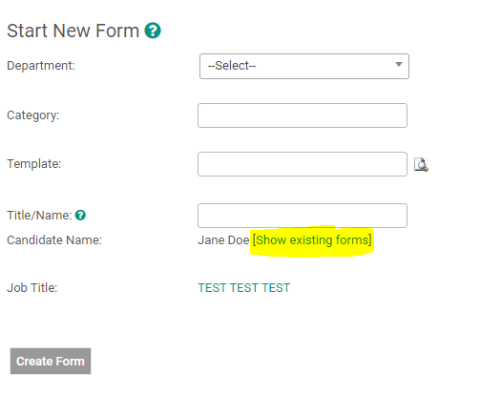
- Click on the job title of the position you are recommending the candidate for.
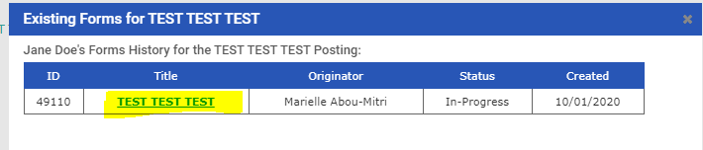
- In order to recommend the candidate for hire in the system, click on “Complete Task” under the Recommendation heading.
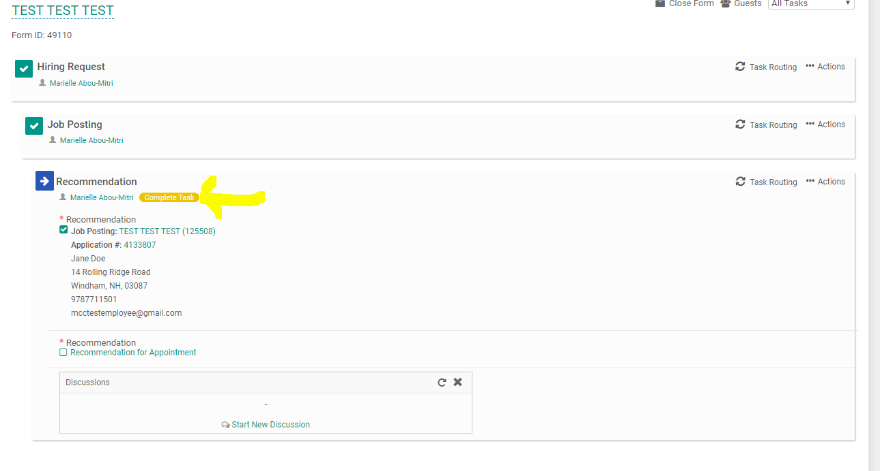
- Now click on the “Recommendation for Appointment” form name.
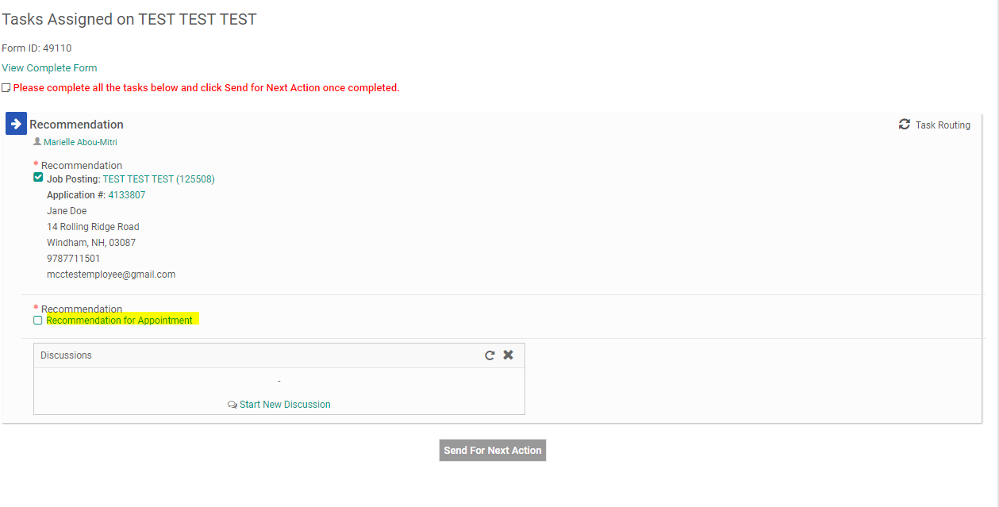
- Fill out the details of the candidate you are recommending to the position. This information includes: (1) Title, (2) Full Name of Candidate, (3) Salary, (4) Approximate Start Date, (5) Supervisor Name, (6) Supervisor Title. When you have completed all the specific information about the candidate click on “Save & Submit”.
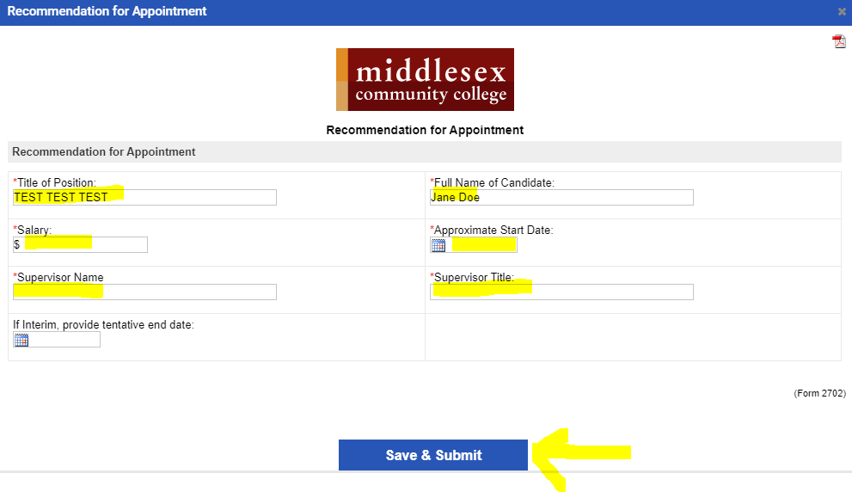
- You will then be prompted to review the information you submitted on the form. You can click “Edit” if you would like to make changes. Otherwise, click “Continue”
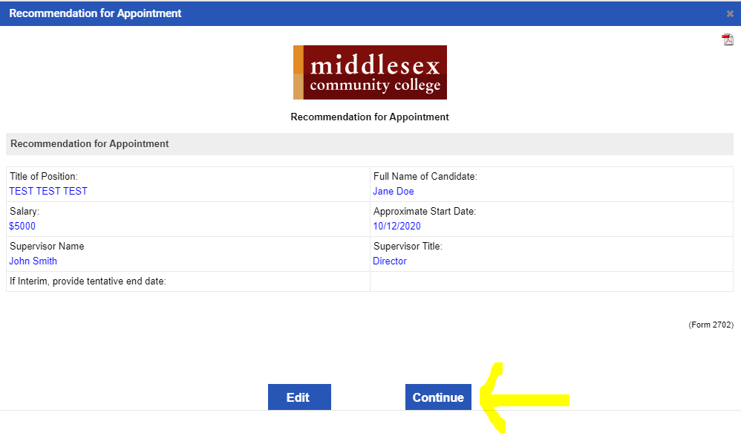
- You will now see that there is a small check mark in front of the form titled “Recommendation for Appointment.” This will confirm that you have completed the form. Next click, “Send for Next Action”
