Noncredit Students - Covid Vaccination Card Upload

- Click on the link below:
Covid Vaccination Card Upload

- You will see a screen asking for General Information and asking you to upload a Photo ID and upload a Selfie (i.e., a picture of yourself). There is a scroll button on the right side of the screen and you can scroll down the page to enter your information and upload your documents.

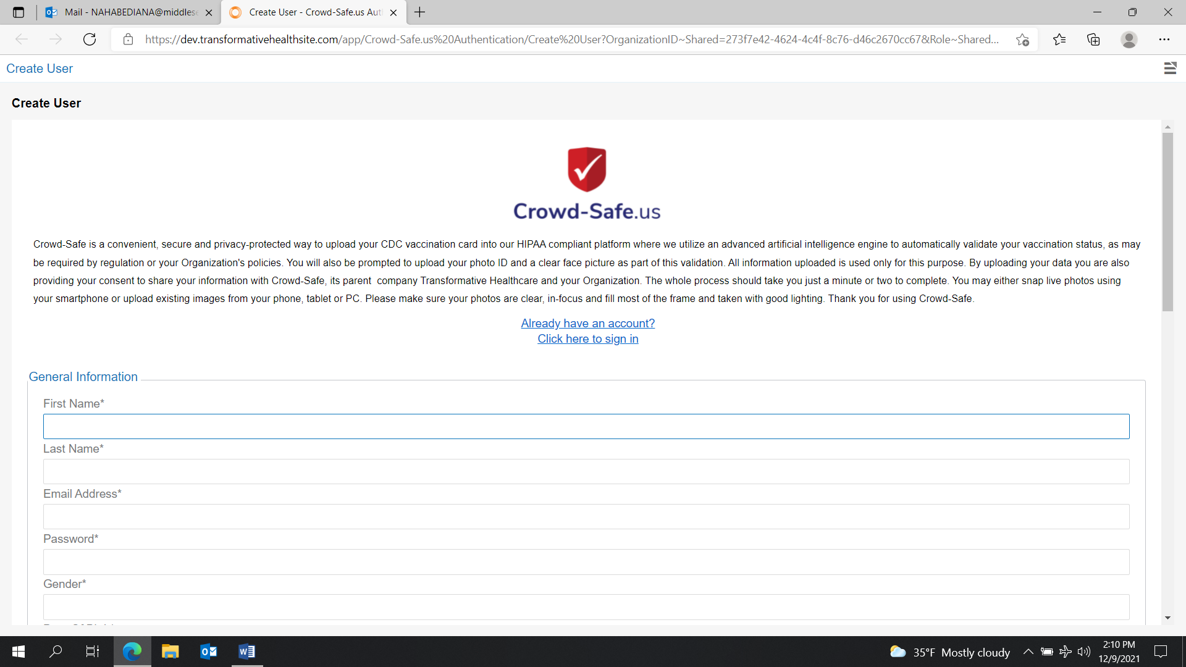

Enter the required information on the form.

General Information
First Name
Last Name
Email Address
Password
Gender (Select Female or Male or Other)
Date of Birth (Format to use: mm/dd/yyyy)

Address
Street Address
City
State (Select the appropriate state)
Zip Code
Country (Select United States of America)

Upload Photo ID
Upload government photo ID (ex. State Issued ID, Driver’s license, Passport, Green Card, Work Visa). You can Drag& Drop your files or click on Browse and pull up your file.

Upload a Selfie
Upload a full faced picture of yourself. You can Drag& Drop your files or click on Browse and pull up your file.

- Click on + Create Account

- You will now see the screen below. Follow the instructions on the screen and upload your Vaccination card. You should receive a message that you have successfully uploaded your vaccine card.
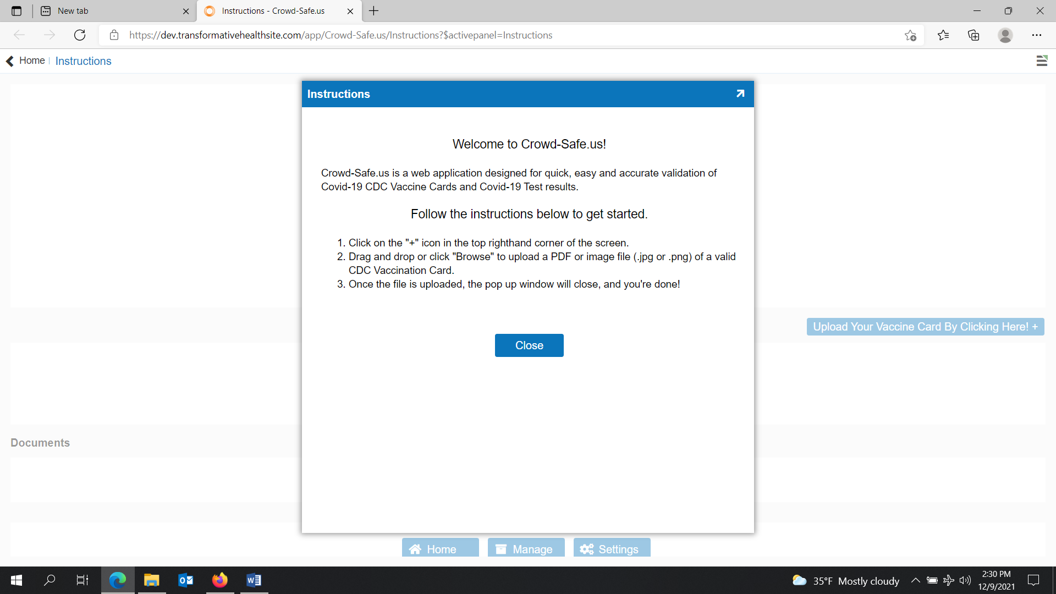

- If you ever need to get back into your account, the email you provided is your Username and the password you just created is your Password.

- If you are having issues in uploading your Covid vaccination card, contact Audrey at nahabediana@middlesex.mass.edu or Teresa at medinat@middlesex.mass.edu.

